DESIGN AND IMPLEMENTATION OF COMPUTERIZED CHILD CARE INFORMATION SYSTEM

By

Amidu Dabor
Zainab Sesay
David Maada Gegbai

SUPERVISED BY
Dr. Hamza
Mr. M. Bangurah

A PROJECT RESEARCH SUBMITTED TO THE
DEPARTMENT OF PHYSICS AND COMPUTER SCIENCE, NJALA UNIVERSITY
IN PARTIAL FULFILLMENT TO THE AWARD OF BSc. (Hons) IN COMPUTER SCIENCE

DECLARATION
This is to certify that this project which was done and written by Amidu Dabor, Zainab Sesay, and David Maada Gegbai has been approved by the Department of Physics and Computer Science, Njala University, in partial fulfillment for the award of Bsc. (Hons) in Computer Science.

……………………………. ……………….
Date
(Project Supervisor).

……………………………. ……………….
Date
(Project Supervisor).

……………………………. ……………….
Date
Head of Department

……………………………. ……………….
Dean Date

DEDICATION

We dedicate this work to Almighty God, our family, friends, lecturers, youtube, stackoverflow, geekforgeeks, and other online learning platforms.
ACKNOWLEDGEMENT

Very sincerely, we first and foremost recognize the grace of God for seeing us through to this level of the project. To the staff and to the entire administration of the Department of Physics and Computer Science, Njala University, we are indebted. In spite of the unimaginable challenges we faced along the paths to our academic pursuits, you made it possible, through mentorship and provision of the appropriate learning platform we needed, to help us realise our full potentials.
This project is a landmark in our academic careers. We have been fortunate to learn theories and concepts which would have been impossible if we had not extensively carried out the needed research. We are grateful to a number of people who have guided and supported us throughout the research process and provided assistance for our venture. We would first like to thank our supervisors, Dr. Hamza and Mr. M. Bangurah, who guided us in selecting the final theme/scope for this research. Our supervisors were there throughout our preparation of the proposal and the conceptualization of its structure. we would not have been able to do the research and achieve learning in the same manner without their help and support. Their recommendations and instructions have enabled us to assemble and finish the project write-up effectively. We would also like to thank all our instructors and teachers, who, throughout our educational career, have supported and encouraged us to believe in our abilities. They have directed us through various situations, allowing us to reach this accomplishment. Finally, our families have supported and helped us along the course of this project by giving encouragement and by providing the moral and emotional support we needed to complete our thesis. To them, we are eternally grateful.
ABSTRACT
This project is centered on computerized child care information system. The current process of keeping of child care information records is being operated manually and due to this procedure, numerous problems are been encountered. A design was taken to computerize the manual process in order to check this problem. The problems were identified after series of interviews and examination of documents after which analysis was made, and a computerized procedure recommended. This project will also suggest how to successfully implement the computerized procedure and to overcome the obstacle that would hinder the successful implementation of the system. The new system was designed as web-based, using HTML, CSS, JAVASCRIPT, MONGODB, and NodeJS technologies. These languages were chosen because of their easy syntax and features for developing web-based applications.

TABLE OF CONTENTS

Cover page

Title page
Certification
Dedication
Acknowledgment
Abstract
Table of content
Organisation of work.

CHAPTER ONE
INTRODUCTION
  - Background of the study
  - Statement of the problem
  - Purpose of study
  - Aims and objectives
  - Delimitation
  - Limitation
  - Assumption
  - Definition of terms

CHAPTER TWO
LITERATURE REVIEW

CHAPTER THREE
3.0 Research Methodology
3.1 Method of Data Collection
3.1.1 Primary Method
3.1.2 Secondary Method
3.2 Process/Information Flow Analysis
3.3 Problem of the Existing System
3.4 Justification of the New System
3.5 Input and Output Design
3.6 File Design
3.7 System Flowchart
3.8 Architectural Design

CHAPTER FOUR
4.1 Introduction
4.2 Program flowchart
4.3 Program source code
4.4 Program Implementation

Chapter Five
5.1 Summary
5.2 Conclusion
5.3 Recommendation

ORGANISATION OF WORK
Chapter one: This chapter introduces the topic of this project, what it is all about, and what is to be achieved. It points out the statement of the problem purpose of the study aims and objective definition limitations and definition of terms.
Chapter two: This chapter reviews the literature on what people have been writing or said about the topic.
Chapter three: This chapter aims at describing and analyzing of the existing system. The method used in fact findings, organisational structure, objective of the existing system, input process, output analysis, information, flow diagram, or chart problem of the existing system and justifications for the new system.
Chapter four: Designing of the new system output and input specification design, file design, procedure chart, system flowchart and system requirement.
Chapter five: It is where the recommendation and the conclusion were made.

CHAPTER ONE
INTRODUCTION

  - BACKGROUND OF THE STUDY
Children are heritage of God, and the fruit of the womb is His reward. As arrows are in the hands of the mighty man, so are children of the youth happy is the man that hath his quiver full of them (Psalm 127:3-5). The African child occupies a strategic position in the family, in the society, and in the nation; which is not an over statement and cannot be underplayed. A child is considered as the life wire of the family and the society at large, to the extent that any couple that is not blessed with a child is looked upon with pity and sometimes sympathized with.
There is the need to know who is a child, and what is child care.
In traditional and even contemporary African homes, various ethnic groups have different concepts of who is a child, while some ethnic groups see one as a child in so far as she can contribute to the development of the society. Some others see it in terms of one who has not yet attained the age of initiation into the age grade.
There is not one acceptable age, which is considered as a worthy definition of the upper limit of childhood. The age at which a child can become capable in law for his or her action is the age at which childhood begins in terms of the right to vote and to be voted for and the age considered by the federal ministry of youth and culture and education as being the upper limit of childhood different. Even internationally there are divergent definitions as to who is a child. Whereas the International Labour Organisation (ILO) and the United Nations (UN) population division refers to a child as those below 18 years of age. The 1989 Convention on the right of the child states that a child means every human being below the age of 18 years. Even though there are divergent opinions and views as to what is the age limit of a child is. It is the views of the authors that a child is anybody between birth to completion of physiologically/ psychological and physical development. In order words, anybody between ages zero of his/her birth to 18 years is a child.
Child care, on the other hand, is a kind of human acts that jeopardizes the physical, psychological, and the featuring of the child either intentionally or unintentionally.
Child care is an implied act of giving basic needs, rights and deeds of a child by parents/guardians, which will pair the well-being of the child. Caring can also take the form of adequate provision of resources for the welfare of the child both now and in future.
Also, there should not be any form of encounter with problems of misplacement of vital (sensitive) information or records as a result of services not being available or being rendered when needed.

1.2 STATEMENT OF THE PROBLEM
In every child care medical center, there are numerous problems that are encountered in regards to maintaining a cost-effective/cost-efficient and a well-organised database management system. A child medical care center like Ola During Children Hospital _ our case study _ encounters problem of the manual system in the area of documentation which includes misplacement of vital information or cases as a result of poor child care data management services that are being used. Duplication of efforts due to inconsistency in activities and in the long time taken in search of a file or of reported cases when needed for processing have not been going so well to uphold efficiency, effectiveness, accuracy, and a well-structured approach of child care data management.
This is the problem that is discovered that promoted for the design and implementation of a computerised child care information system to enable the aforenamed hospital to work more effectively.

1.3 PURPOSE OF STUDY
The purpose of this study is to design and implement a computerised system that will eliminate the above stated problems, as in misplacement of relevant information and files such as reported cases, documents, records, duplication of efforts and the long time that is required during searching and processing of cases and files.

  - AIMS AND OBJECTIVES
The objective of the project is to study how Ola Durin Children Hospital operates with managing its child care records, on which through thorough research/observations, a suitable design and implementation of a computerised solution can be provided.
It aims at detecting problems that pose obstacle with a view of modifying the operations and developing a new system that will be more efficient and accurate such as:
In the area of misplacement of vital documents, a computer will be used to record, and retrieve large volume of documents which will reduce the duplication of efforts due to inconsistency in activities and in the long time taken in search of files when they are required for processing.

  - DELIMITATION/ SCOPE OF THE STUDY
This study is specifically concerned with the computerized child care and carrying of the Ola During Children’s Section of Cottage Hospital. Although a lot of activities are being performed by this center, this work is therefore concerned with childcare and caring manipulation of both the care and reporter of a case.

  - LIMITATION OF THE STUDY
The key limitations of our study are lack of time and other required resources. The study focuses on a specific area concerned with tracking and keeping records of all clients and personnel and processing them using a computer.
We could not obtain much relevant data from the administration of the named children hospital to add to enhance the work of our project. This prompts us to use data samples from external data sources on different online and offline child care medical management systems.
In spite of the hinderance of time and other resource factors, we could make a good start which has now led us to a higher level of the development process.

1.7 ASSUMPTION
Apparently, before starting this work, we assumed a successful completion by division, grace of God, and the cooperation of workers of Ola During Children Hospital in supplying us with data/information needed for the successful completion of this project.
In terms of material resources, monetary, and personnel resources, we were unable to meet up with them. In terms of the fact, it is believed that they are valid.

1.8 DEFINITION OF TERMS
A child: A child means every human being below the age of 18 years unless under the law applicable to the child majority is attained
Childcare: That is any kind of human act that jeopardizes the physical, psychological, and the futurity of the child either intentionally or unintentionally.
Child caring: This implies the act of giving basic needs, rights, and deals of the child by parents/guardians, peers, government, and cultural community which will pair the well-being of a child. Caring can also take the form of adequate provision of resources for the welfare of the child both now in the future.
Flowchart: This is the graphical representation of the logical steps and sequences involved in a procedure or program.
Data: This can be defined as groups of non-random symbols (words value figures) which represent things that have happened.
Information: This is the resource that enables the collection, management, control, and dissemination of information throughout an organisation.
Monitoring: This is to keep watch and see who denies children their rights, and take the necessary steps to stop this.

CHAPTER TWO

2.0 LITERATURE REVIEW
Computerization is the process of building a new system upon a computer technology for input, output, processing and storing. Computer entirely replaces the manual system that is using only paper, and pencil for processing.

Barba D.L.A (1979), in his contribution, says that computerization does not only involve computer technology consisting to only hardware and software but also the communication link, that is, it establishes the link for data communication devices to interact and share data as well as transferring data/information from one location to another. Besides, computers can be used for keeping records and these records are always available whenever they are needed, and the need of carrying office file from one place to another is eliminated, and in most cases, some document may get lost or be tampered with during transfer.

Davies D.W (1979) states that, computers have replaced manual technology because of its ability to process large volume of data or even handle complex work (processing capability) at a very high speed. It gives out accurate result at each time except when it is fed with incorrect data, Garbage-in-garbage-out. Hence, the need for computerization is certified.
In Hospitals, computerization helps to keep accurate patients records in which case, one can call up a patient’s record to find out necessary information about the patient when needed. This also helps to reduce redundancy in collecting patient’s record and also eliminate the problem of missing of some patient’s files.

Also, French CS. (1996) states that, a file is a document stored in the computer individually by name and is organized in a particular way with a well-defined structure consisting of a collection of records each of which are made up of files.

Henry C.L. commented that a typical organisation has a large number of files, many of which may be stored on a computer device. We call these data machine readable because one can use computer to process them. Paper files on the other hand are much less accessible. A large organisation of related files are part of a database.

French C.S also defined a database as a single organised collection of structured data stored with a minimum of duplication of data items so as to provide a consistent user of the system but is independent of programs that use the data. Databases are normally set up in order to meet the information needs of major parts of an organisation. It is not possible to construct a database in a single operation; it is usually a built-up section. During this process, it is possible to:
- Add new “files” of data.
- Delete existing data
- Add new or update fields to record(s) already present in the database.
- Create relationships between the data.
A database requires data being stored on large capacity direct access devices. The usual medium is the magnetic disk. For security purposes a copy of the database may be held on magnetic tape or disk.
Like in some clinics and general out-patients departments, patient’s data may be duplicated, it is important to realize the duplication are minimized and controlled. This is referred to as controlled redundancy.

Although to the user, the database may appear as a collection of files, data in database is organized in a more complex way than data in conventional files. Database may be classified according to the approach taken to database organisation. The classes are relational, network, hierarchical and file inversions. But this project work discusses more on non-relational database (information system) that is: it uses collections and documents.

Data description must be standardized for this reason. A data description language (D.D.L.) is provided which must be compared to the declarations and processing statement in a conventional programming language.

Since complex files are processed in the database, a complex software system called database management system is required for construct, expansion and maintenance of the database. It provides the controlled interface between the user and the data in the database. The DBMS allocated storage of data.

It maintains indices so that any required data can be retrieved and so that separate items of data in the database can be cross-referenced. The DBMS provides facilities for different types of file processing such as processing a complete file (serially or sequentially), process required records (selective sequential or random), and retrieve individual records. It has the function of providing security for the data in the database.
Kent (1983), present a set of guidelines to make NORMALIZATION more intensive. First normal form requires that all occurrence of a record type contain the same number of fields. As a result, a record cannot contain repeating groups of data. Second normal form requires the design to examine the relationship between key field and other field in the record. In general, normalization creates a database in which there is minimum redundancy of data and risk of demanding the database through updating is minimized.

Most computerized systems cannot accept data in forms that are customary to human communication such as speech or hand written documents. It is necessary therefore to present data to the computer in a way that provides easy conversion into its own electronic pulse-based form. This is commonly achieved by typing the data into keyboard devices that convert it into machine sensible forms. Data finally enters storage.

Grawhill M.C draw a distinction between data and information. By using the description between information storage and retrieval rather that storage and retrieval that emphasis is firmly placed upon something meaningful to a user rather than upon the technicalities of storage. He also stressed that the more the meaning that was to be represented and stored, the more complex the storage organisation and structure must be. As records are stored in these systems their contents are automatically indexed by the software. Subsequently, the use may be able to find every instance of selected record very quickly.

A general conclusion drawn from this is that, the data to be processed by the computer must be collected. The process of data collection then involves getting the original data, converting it from one medium to another, and finally getting it into the computer.

Abudullahi, J.I defines data collection as the process involved in getting the data from its points of original collection. It starts at the services of raw data and ends when valid data is within the computer in a form ready for processing. The process of data collections may involve any number of the following depending on the method used which includes the following:
- Data creation.
- Transmission of data.
- Data preparation.
- Possible conversion from one medium to another.
- Input of data to the computer from validation.
- Sorting
- Control-all stages must be controlled

Also, in processing the patients’ record, data control measures should be involved. The following measures are stated below:
- Manual controls
- Data collection controls
- Validation checks

Batch controls to ensure that all data is processed, preserving the integrity of maintained data, deleted, corrected and reprocesses all errors.
CHAPTER THREE

SYSTEM INVESTIGATION ANALYSIS AND DESIGN OF INPUT/OUTPUT SYSTEM

3.0 RESEARCH METHODOLOGY
Research is an investigation in order to discover new factors through planning and systematic collection, analysis, and interpretation of data, whereas particular task, therefore, research methodology is a detailed description of what the researcher planned and procedure adopted in gathering new facts relevant to the project work.

It is therefore an established fact that without data, there can be no analysis. This is the crux of social science research. Data can be defined simply as basic facts and figure mostly numeric in nature, resulting from business economic and social activities of man.

3.1 METHOD OF DATA COLLECTION
In the course of this project, the following outlines the method of data collection used.
- Primary method
- Secondary method

3.1.1 PRIMARY METHOD
The direct observation method was used.
OBSERVATION
Some facts were recorded through our observation of some activities carried out on children care record in the named hospital.

3.1.2 SECONDARY METHOD (OTHER METHOD)
Other method we used in data collection, as stated, was deductions from the children care record and hand book or cards in the hospital, online.

3.2 PROCESS/INFORMATION FLOW ANALYSIS
The highest profile from which information flows and are processed is “The admission while the lowest is “the children” in between this terminal are several departments whose functions are definitely instrumental to the effective and efficient processing as well as circulations of data. As you go from down (children level) to up (admission), facts and figures are passed in form of data while as you descend from highest to lowest, facts and figures are passed on as information. Below shows the trend of process information flow analysis of children’s record in the hospital.

INFORMATION FLOWCHART
DIRECTOR
HEAD OF ADMIN. SERVICE
DEPUTY DIRECTOR PHARMACY
HEAD OF CLINICAL SERVICES
CHILDREN
HEALTH WORKERS

3.3 PROBLEM OF THE EXISTING SYSTEM
The problems that are obtainable from the existing system are inherent mostly from the current method of operation (The manual method) which includes the following:

LACK OF OFFICE SPACE
This is due to many working materials like files, paper, cartoons, shelves etc. that must be accommodated.

MANUAL LIMITATION
Many processes demand high mental exercise and care which if not properly carried out might cause errors in the records due to complexities of the processing.

MISSING ITEM
Most time, children’s records or even files are out of place. This can be caused by not being careful, oversight, over-stressed by any of such unpredictable factors.

TIMELINESS
Despite the high staff turnover, information is not usually prepared on time. Comprehensive laboratory result sheet, statement of laboratory result reference list etc. are usually never ready at the appropriate time.

POOR SECURITY
There is not enough security to keep data from unauthorized personnel. This means that in critical cases, records can be altered without due formalities.

RECORD UPDATE IS DIFFICULT
Due to the fact that records can only be searched out by going through file shelves, it becomes more tedious as opposed to glance some data which are operations, but mishandled the following are the inputs patients Name(surname), other Names, lab. No, provisional diagnosis, investigation required, sex, Age, Date, Health Institution etc.

3.4 JUSTIFICATION OF NEW SYSTEM
The initial problem of the existing system as outlined above hinders efficiency in the Institution and reduces effectiveness in data processing. That notwithstanding, initial changes and other crucial analysis require lots of labour and mathematical calculations which are perhaps quite numerous and complex.

A computer is known for its capability to perform complex and routine functions satisfactorily, notably difficult for man. Computerization therefore offers the benefits of cost and labour effectiveness, for Ola During Children Hospital to meet up with challenges of modern data processing. This has greatly motivated the design of this new system. Objectively, the system will provide computer-based tools and designs, suitable and technically acceptable for the COMPUTERIZED CHILD CARE INFORMATION SYSTEM.

3.5 INPUT AND OUTPUT DESIGN
Data fed into the system tells more about the output desired for this project, the user shall input data via the keyboard, initialize command via the keyboard or with the aid of a backing storage. Then the output processed data can be accessed from the monitor, or stored in the online system database, the following describes the data design for the new system.

INPUT DATA (DESIGN)
  - FILE DESIGN
File are sets of records which must be retained over a number of operational cycles of the system, because of the volume of information that computer holds in storage-keeping where other storage tools are limited. Filing is adopted to hold records in this case. Specially, random are used in this project.

3.7 SYSTEM FLOWCHART
KEYING OF PATIENT
DATA (KEYBOARD)
DISPLAY INPUT ON THE SCREEN
(VDU)
PROCESSING DATA (CPU)
DATABASE
FILE
(FILE)
PRINTING OF THE OUTPUTS
(PRINTING)

3.8 ARCHITECHURAL DESIGN
ABOUT FORM
START
EXIT
PASSWORD
SPLASH FORM
MENU FORM
TABLE FORM
CHILD RECORD FORM
RELATIVE FORM
TEMPORARY FORM
REFERENCE FORM
PRINT FORM

CHAPTER FOUR
PROGRAM TESTING AND IMPLEMENTATION
  - INTRODUCTION
The program design was considered in the following two areas:
1) Modular design: Creation of modules was necessary since we realize that the system would be made of different units which would be somewhat difficult to design as one whole unit. We therefore created representative modules for the complex whole.
2) Actual Design: At this point, the individual modules so far created were transformed into actual working design. This design stage involves the creation of forms and placing of necessary objects on these forms.

  - PROGRAM FLOWCHART (APPENDIX 1)

  - PROGRAM SOURCE CODE (APPENDIX II)
Users Login
const mongoose = require("mongoose");

const userSchema = new mongoose.Schema({
name : String,
email : String,
password : String,
role : String,
created : {
type : Date,
default : Date.now()
}
});

module.exports = mongoose.model("User", userSchema);

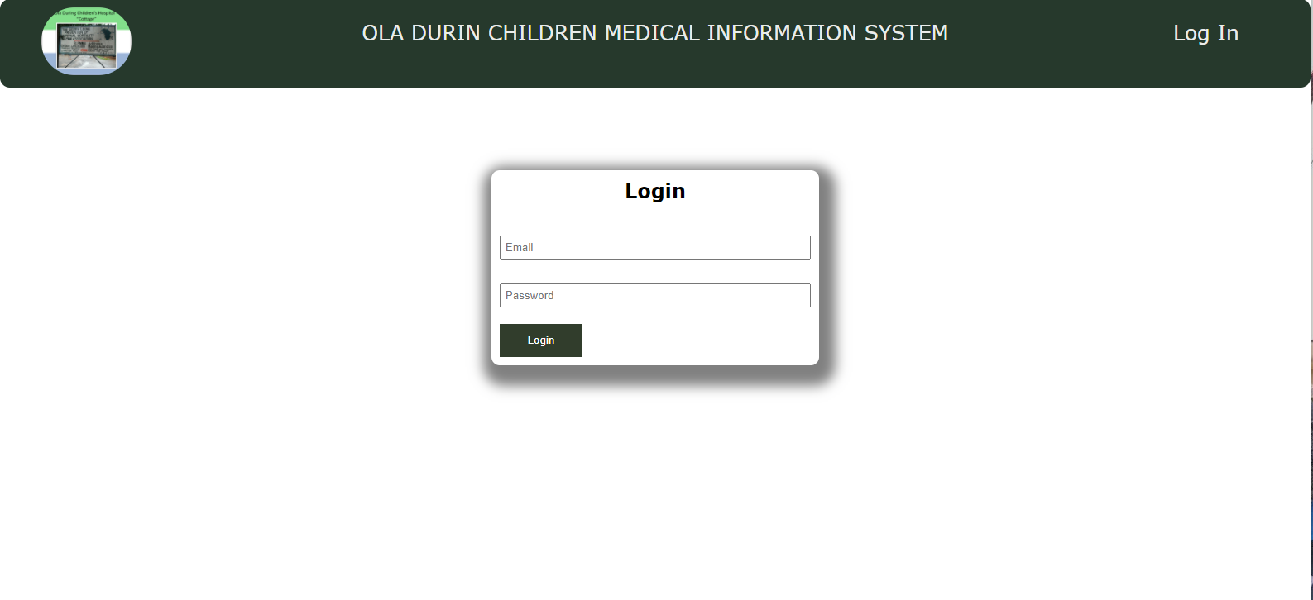

Child

const mongoose = require("mongoose");

const childSchema = new mongoose.Schema({
childID : String,
firstName : String,
lastName : String,
otherName : String,
dob : String,
gender : String,
address : String,
photo : String,
ethnicity : String,
religion : String,
nationality : String,
registrationType : String,
regDate : Date,
mother : {
type : mongoose.Schema.Types.ObjectId,
ref : "Mother"
},
father : {
type : mongoose.Schema.Types.ObjectId,
ref : "Father"
},
guardian : {
type : mongoose.Schema.Types.ObjectId,
ref : "Guardian"
}
});

module.exports = mongoose.model("Child", childSchema);

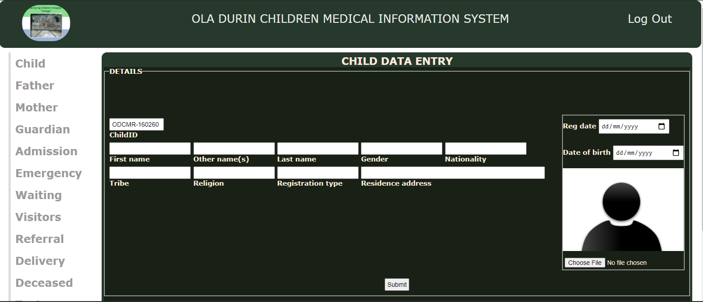

Father

const mongoose = require("mongoose");

const fatherSchema = new mongoose.Schema({
fatherID : String,
firstName : String,
lastName : String,
otherName : String,
gender : String,
dob : Date,
address : String,
contact : String,
nationality : String,
placeOfBirth : String,
maritalStatus : String,
occupation : String,
photo : String,
childId : String,
educationalLevel : String,
noOfChildren : String,
regDate : {
type : Date,
default : Date.now()
}
});

module.exports = mongoose.model("Father", fatherSchema);

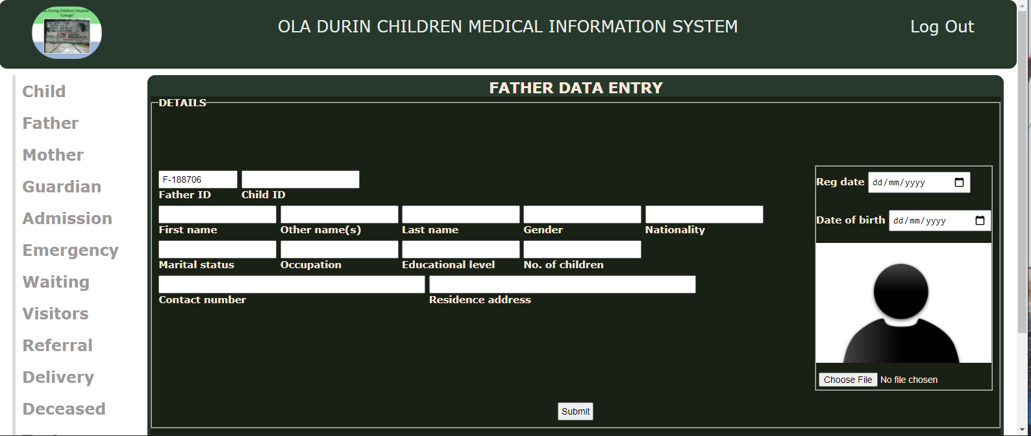

Mother

const mongoose = require("mongoose");

const motherSchema = new mongoose.Schema({
motherID : String,
firstName : String,
lastName : String,
otherName : String,
gender : String,
dob : Date,
address : String,
contact : String,
nationality : String,
placeOfBirth : String,
maritalStatus : String,
occupation : String,
photo : String,
childId : String,
educationalLevel : String,
noOfChildren : String,
regDate : {
type : Date,
default : Date.now()
}
});

module.exports = mongoose.model("Mother", motherSchema);

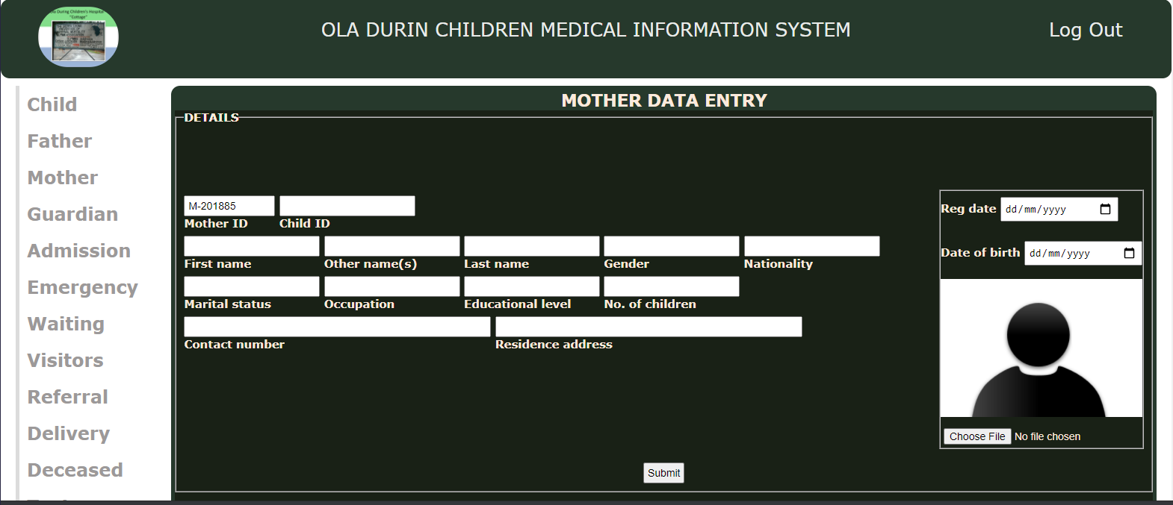

Guardian

const mongoose = require("mongoose");

const guardianSchema = new mongoose.Schema({
guardianID : String,
firstName : String,
lastName : String,
otherName : String,
gender : String,
dob : Date,
address : String,
contact : String,
nationality : String,
placeOfBirth : String,
maritalStatus : String,
occupation : String,
photo : String,
childId : String,
educationalLevel : String,
noOfChildren : String,
regDate : {
type : Date,
default : Date.now()
}
});

module.exports = mongoose.model("Guardian", guardianSchema);

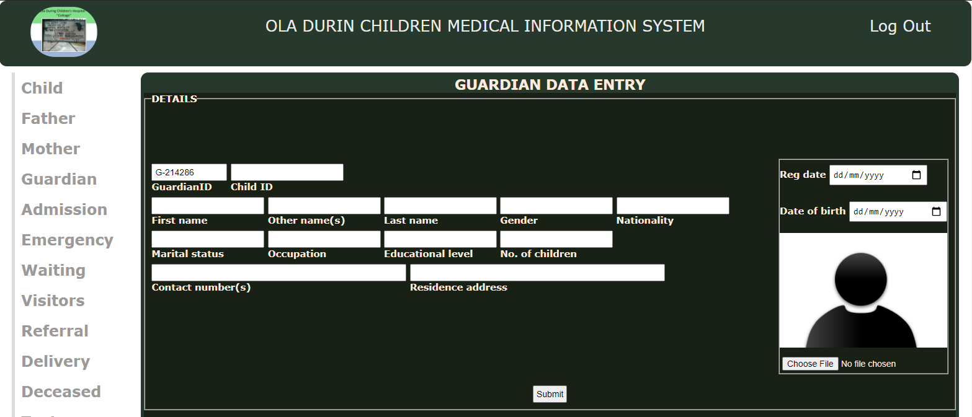

Admission

const mongoose = require("mongoose");

const admissionSchema = new mongoose.Schema({
admissionID : String,
ward : String,
bedNumber : Number,
admittedDate : {
type : Date,
default : Date.now()
},
childID : String,
admissionDetail : String,//Detail regarding why the child was admitted
specialist : String,
wardDescription : String
});

module.exports = mongoose.model("Admission", admissionSchema);

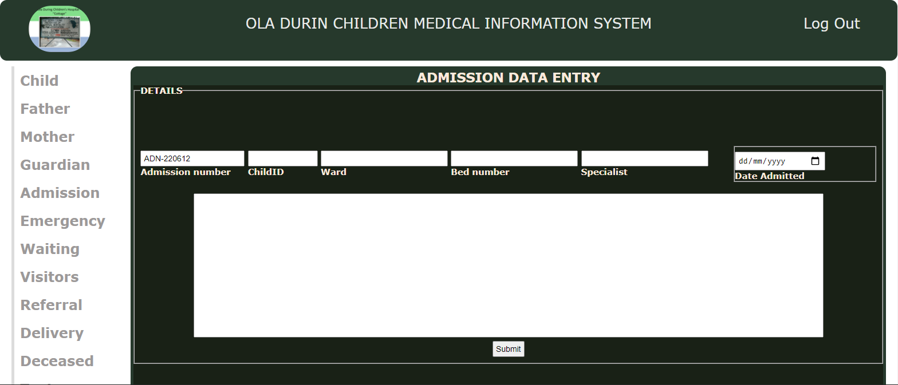

Emergency

const mongoose = require("mongoose");

const emergencySchema = new mongoose.Schema({
emergencyID : String,
childID : String,
regDate : String,
emergencyDescription : String,
broughtBy : String,
bringersContact : String,
relationship : String
});

module.exports = mongoose.model("Emergency", emergencySchema);

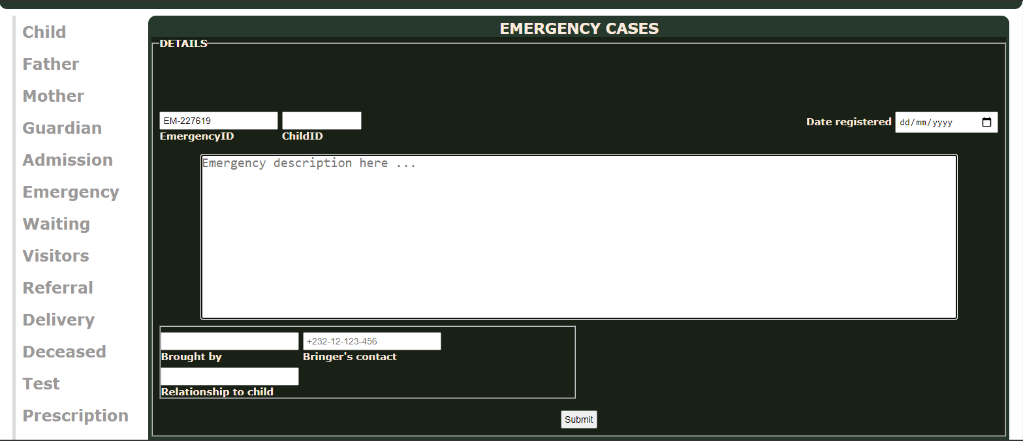

Waiting

const mongoose = require("mongoose");

const waitingSchema = new mongoose.Schema({
waitingID : String,
childID : String,
specialist : String,
status : String,//Status of the waiting patient
waitingFor : String,//What the patient is on the waiting list for
waitingDate : String//When the patients information was entered into the waiting list
});

module.exports = mongoose.model("Waiting", waitingSchema);

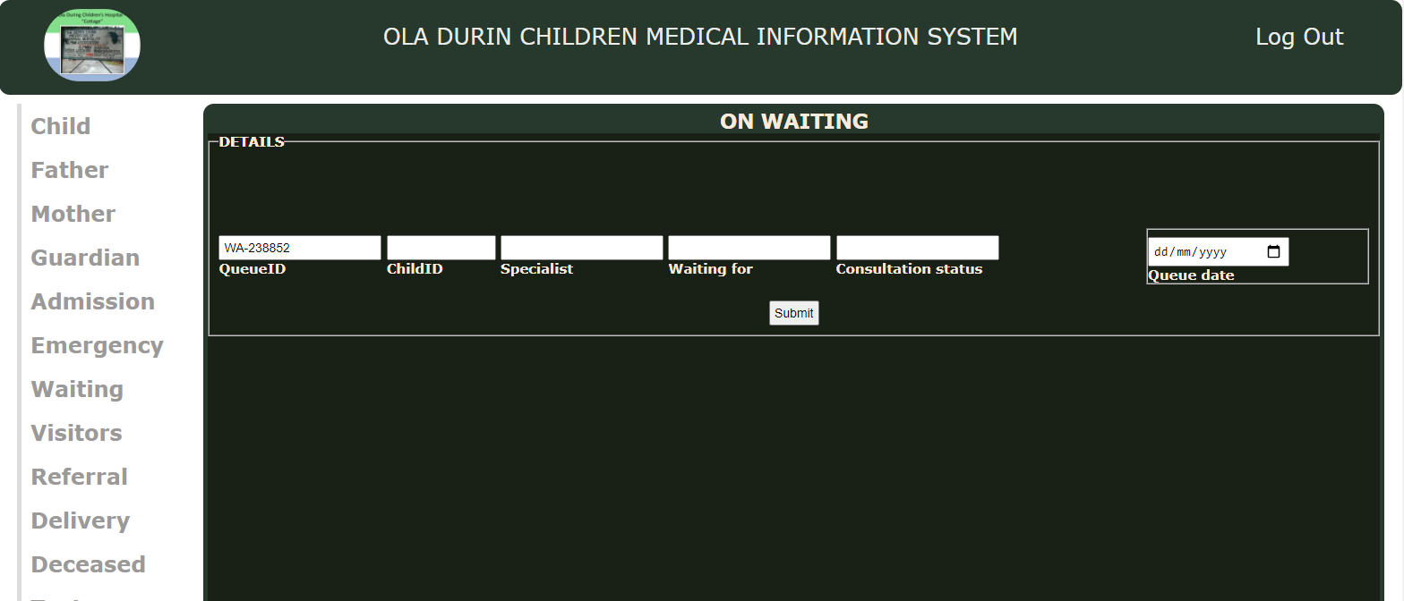

Visitors

const mongoose = require("mongoose");

const visitorsSchema = new mongoose.Schema({
visitorsID : String,
name : String,
childID : String,
purpose : String,
date : {
type : Date,
default :Date.now()
}
});

module.exports = mongoose.model("Visitors", visitorsSchema);

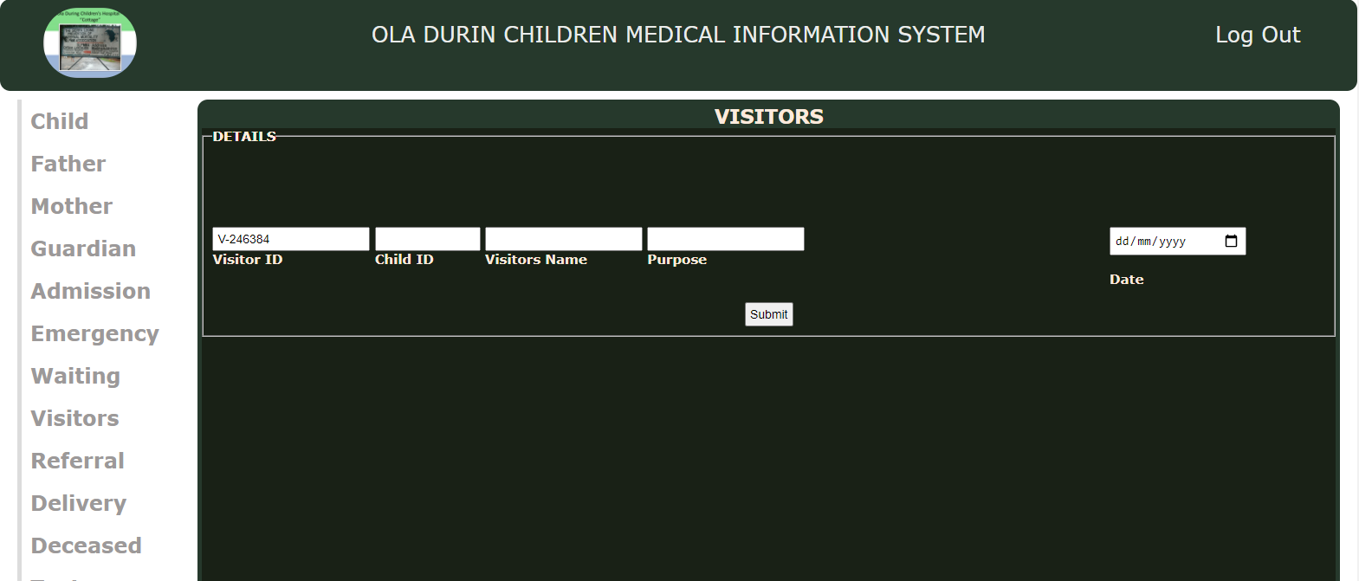

Referral

const mongoose = require("mongoose");

const referralSchema = new mongoose.Schema({
referralID : String,
childID : String,
referredTo : String,//Specialists to whom the child's case has been referred to
fromClinic : String,
toClinic : String,
date : {
type : Date,
default : Date.now()
},
time : String
});

module.exports = mongoose.model("Referral", referralSchema);

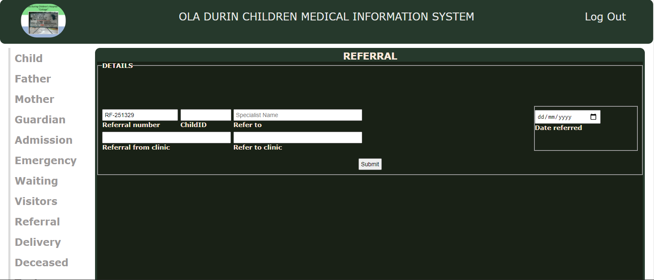

Delivery

const mongoose = require("mongoose");

const deliverySchema = new mongoose.Schema({
deliveryID : String,
childID : String,
fatherID : String,
motherID : String,
placeOfDelivery : String,
typeOfDelivery : String,//Whether normal/natural or CS
deliveryRegDate : {
type : Date,
default : Date.now()
},
dateDelivered : {
type : Date,
default : Date.now()
},
timeOfDelivery : String,
registrationCentre : String,
deliveredBy: String //Name of Doctor / midwife / nurse in charge
});

module.exports = mongoose.model("Delivery", deliverySchema);

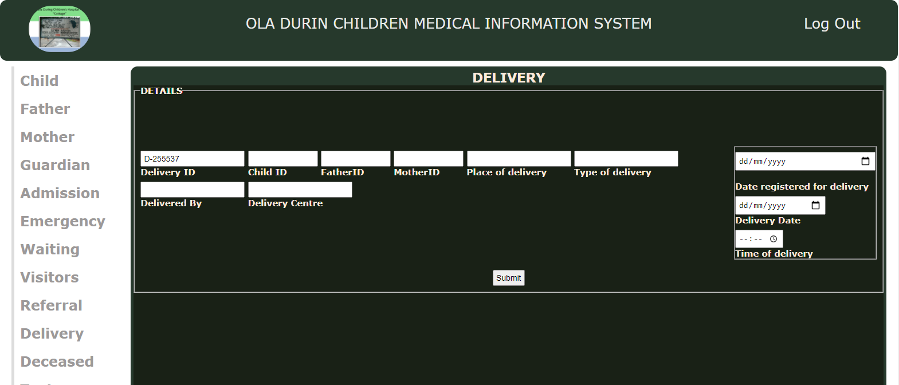

Deceased

const mongoose = require("mongoose");

const deceasedSchema = new mongoose.Schema({
deceasedID : String,
timeOfDeath : String,
date : {
type : Date,
default : Date.now()
},
reportedBy : String, //Name of person that reported the death case
causeOfDeath : String, //Use CKEDITOR to enter the cause of death
childId : String,
residenceAddress : String,
assumedAreaOfIncident : String,
areaOfIncident : String,
tribe : String,
nationality : String,
gender : String,
lastName : String,
otherName : String,
firstName : String
});

module.exports = mongoose.model("Deceased", deceasedSchema);

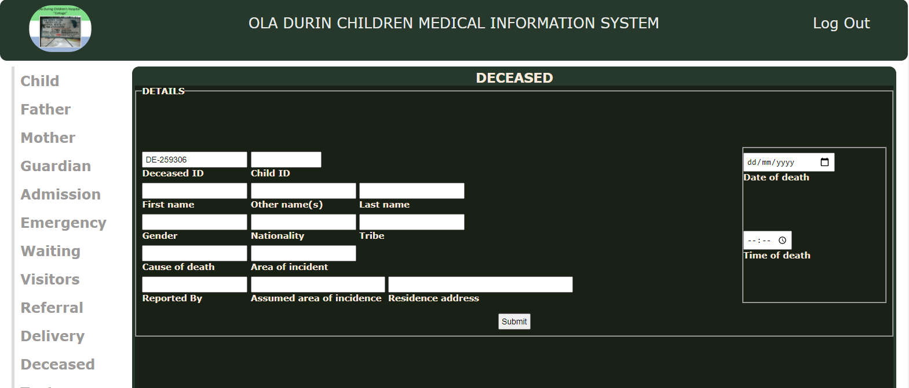

Test

const mongoose = require("mongoose");

const testSchema = new mongoose.Schema({
type : String,//Type of test
requestedBy : String,//The person that requested the test results
labResult : String, //Should be a pdf file or image of the test result
childID : String,//ID of the child that took the test
done :{
type : Date,
default : Date.now()
}
});

module.exports = mongoose.model("Test", testSchema);

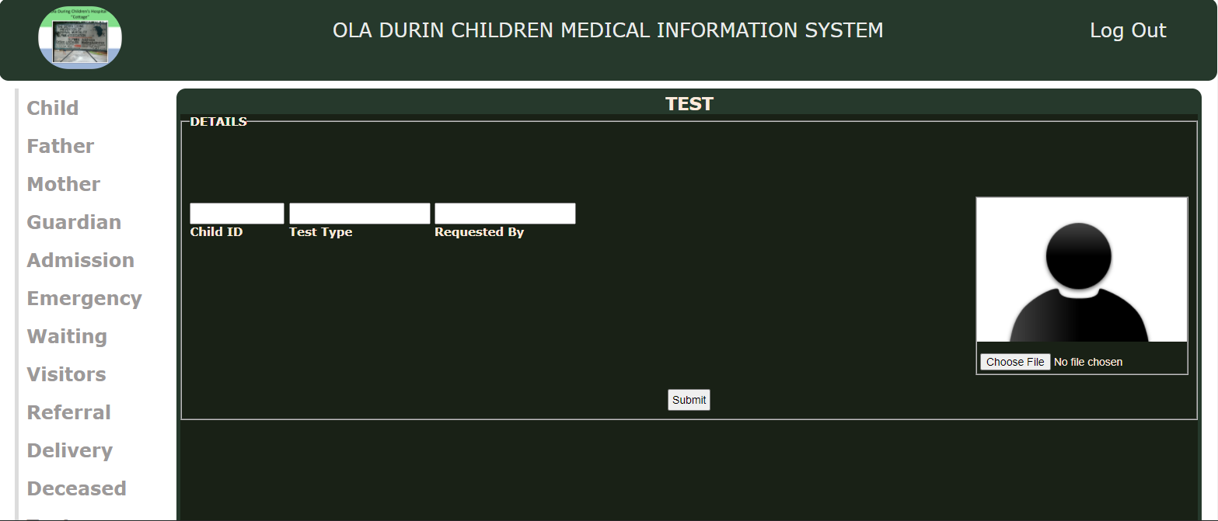

Prescription

const mongoose = require("mongoose");

const prescriptionSchema = new mongoose.Schema({
doneBy : String, //Name / ID of person that did entered the prescription
prescription : String, //Use CKEDITOR to enter the prescription for the child
created : {
type : Date,
default : Date.now()
},
childID : String,//ID of the child for whom the prescription was made
sickness : String//The sickness for which the prescription was done
});

module.exports = mongoose.model("Prescription", prescriptionSchema);

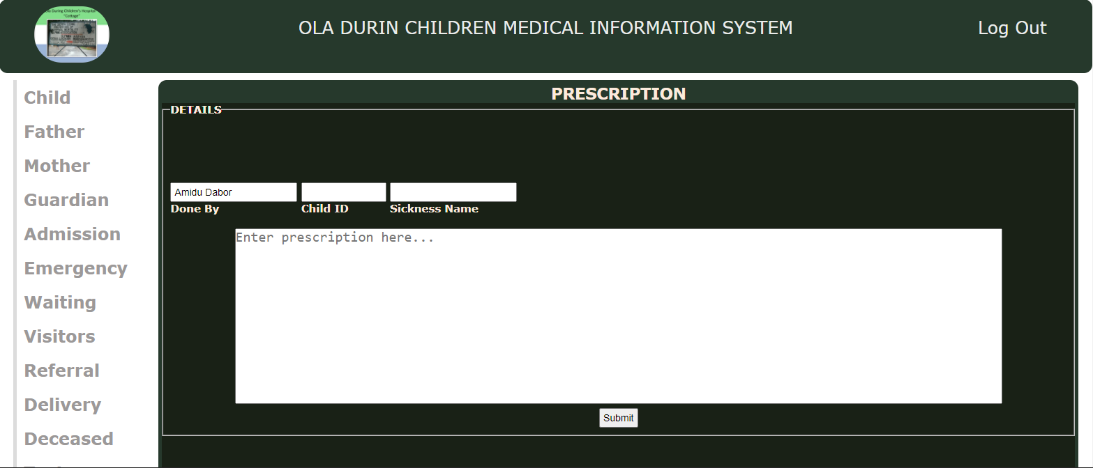

User Profile

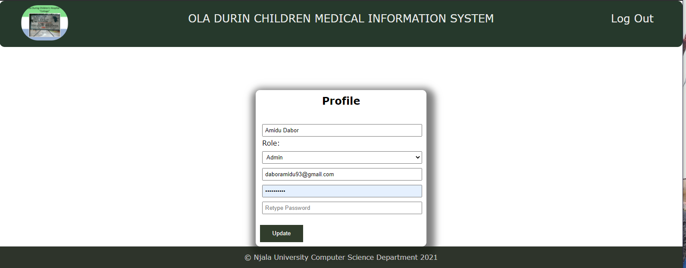

Search Form (Contains a dropdown list of forms with records to search for and display via ID’s)

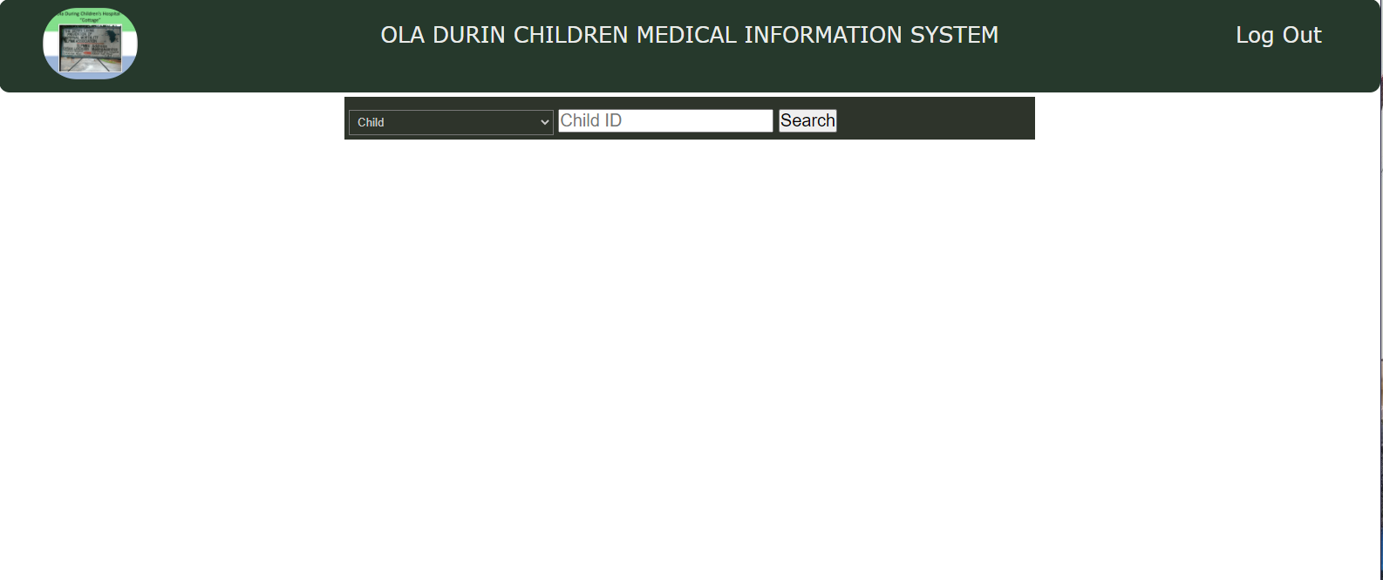

Users Signup Form

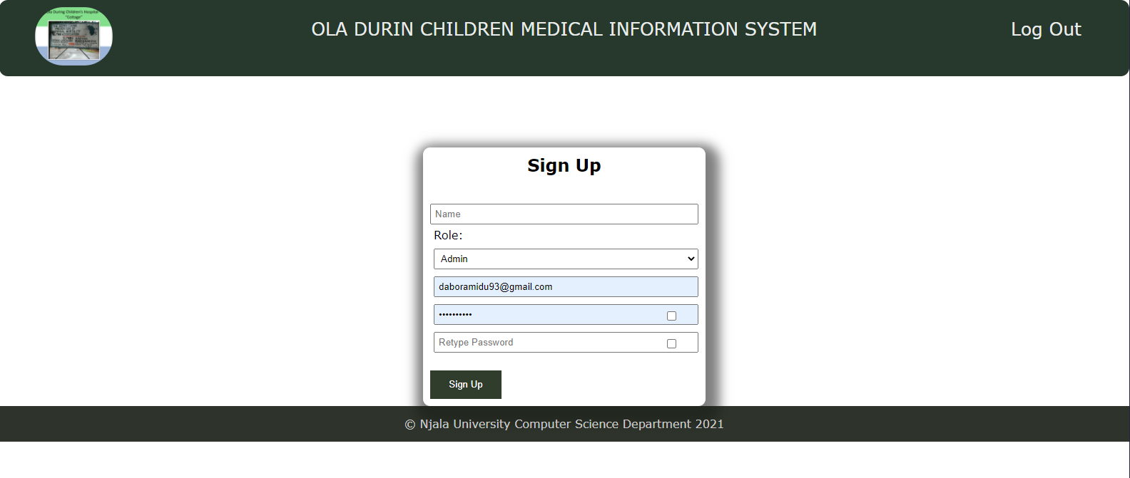

Records of Registered Users

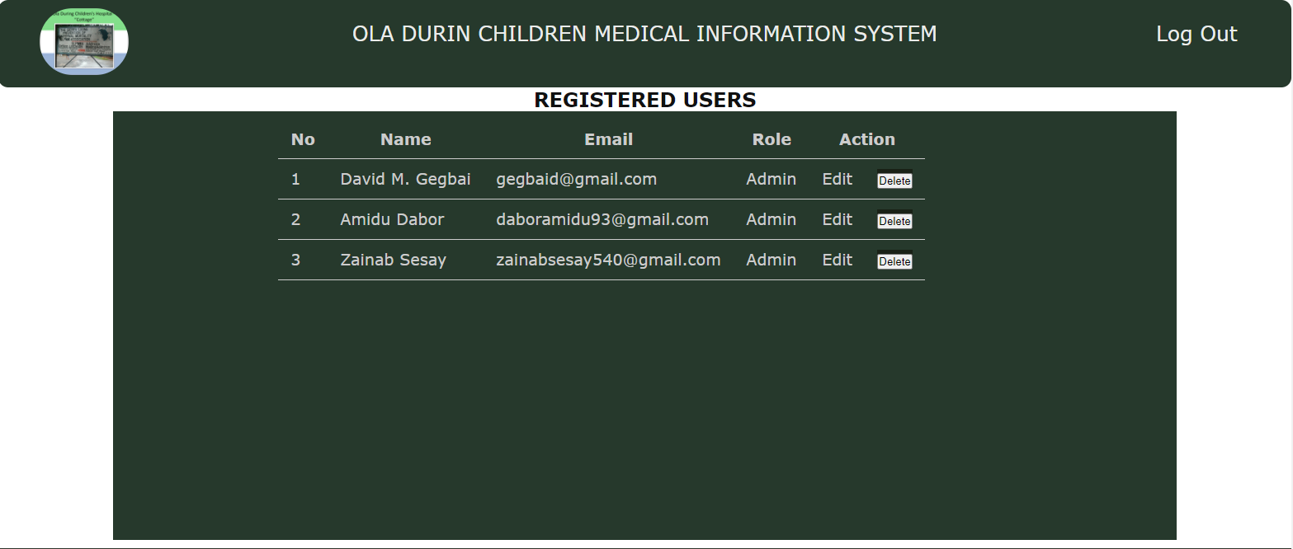

Reports

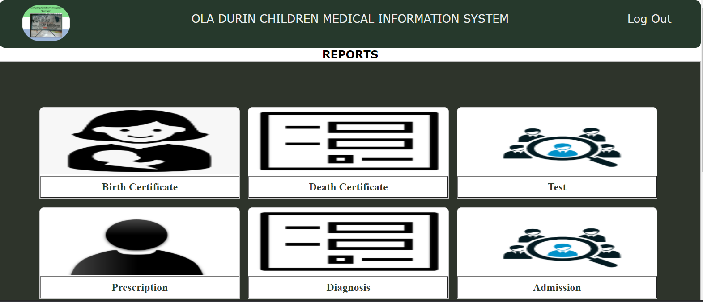
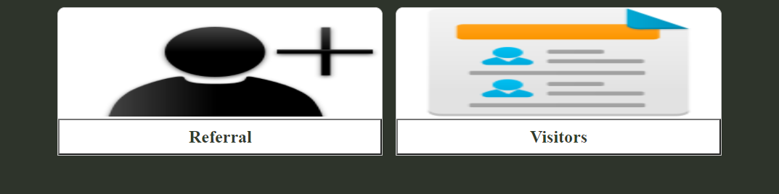

Reports (Contains a dropdown list of reports with records to make queries from via ID’s)

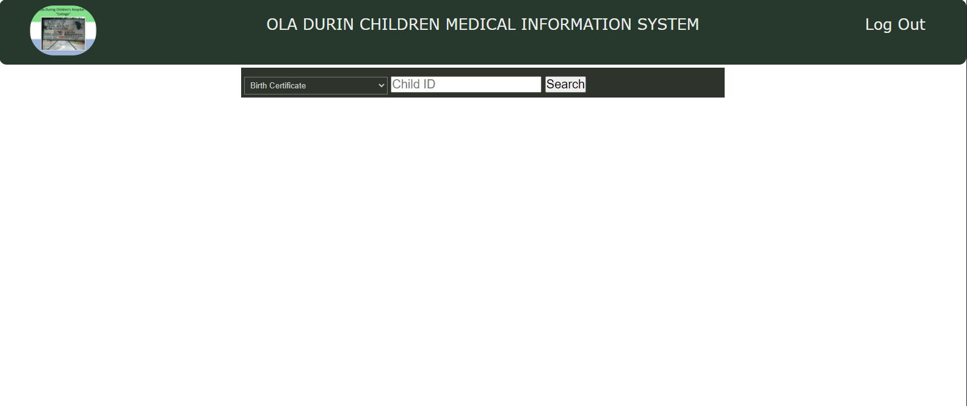

Deleting Records (Contains a dropdown list of forms with records to search for and delete via ID’s)

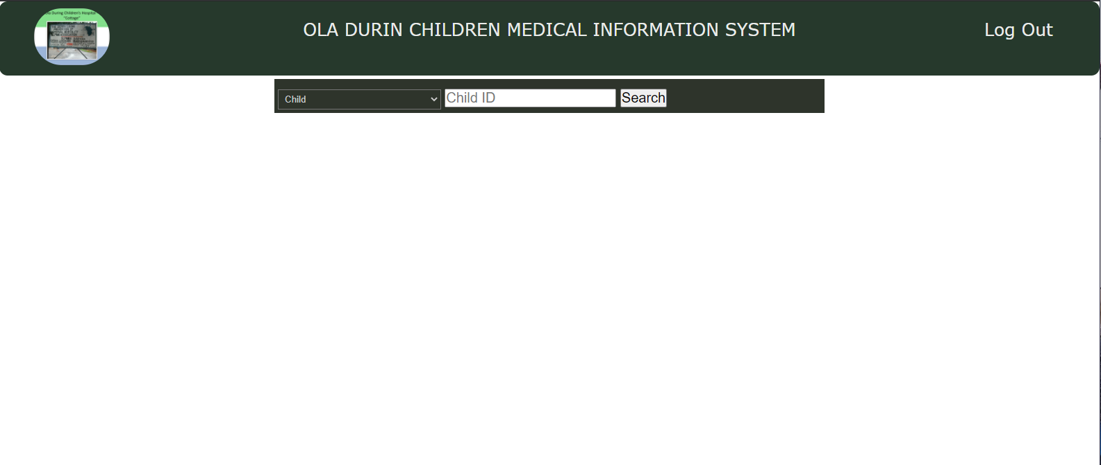

Routing the models

const express = require("express"),
passport = require("passport"),
bcrypt = require("bcryptjs"),
User = require("../models/user"),
Child = require("../models/child"),
Father = require("../models/father"),
Mother = require("../models/mother"),
Guardian = require("../models/guardian"),
Admission = require("../models/admission"),
Emergency = require("../models/emergency"),
Waiting = require("../models/waiting"),
Visitors = require("../models/visitors"),
Referral = require("../models/referral"),
Delivery = require("../models/delivery"),
Deceased = require("../models/deceased"),
Diagnosis = require("../models/diagnosis"),
Prescription = require("../models/prescription"),
Test = require("../models/test"),
Ward = require("../models/ward"),
mongoose = require("mongoose"),
nodemailer = require("nodemailer"),
crypto = require("crypto"),
path = require("path"),
multer = require("multer"),
Grid = require("gridfs-stream"),
GridFsStorage = require("multer-gridfs-storage");
// const prescription = require("../models/prescription");

const router = express.Router();

//CONFIG
require("dotenv").config();
const transporter = nodemailer.createTransport({
service : "gmail",
auth: {
type : "login",
user : "childrensmedicalrecords@gmail.com",
pass : "oladurin"
}
});

//HANDLING FILES
const URI = process.env.MONGODB;
global.Promise = mongoose.Promise
const conn = mongoose.createConnection(URI, {
useUnifiedTopology : true,
useNewUrlParser : true,
useFindAndModify: false
});

//GRIDFS CONFIG FOR IMAGES
let gfs;
conn.once('open', () => {
gfs = Grid(conn.db, mongoose.mongo);
gfs.collection("files");
});

//GRIDFS STORAGE CONFIG
const storage = new GridFsStorage({
url: URI,
options : {useUnifiedTopology : true},
file: (req, file) => {
return new Promise((resolve, reject) => {
crypto.randomBytes(16, (err, buf) => {
if (err) {
return reject(err);
}
const filename = buf.toString('hex') + path.extname(file.originalname);
const fileInfo = {
filename: filename,
bucketName: "files"
};
resolve(fileInfo);
});
});
}
});

//MULTER CONFIG FOR IMAGES
const files = multer({ storage });

//LOGIN CHECKER
const isLoggedIn = ((req, res, next) => {
if(req.isAuthenticated()){
return next();
}else{
res.redirect("/login");
}
});

//Login Route
router.get("/login", (req, res) => {
res.render("login", {
title : "Login to the system",
description : "Logging in to the Ola Durin Childrens Medical Records System"
});
});

//Login Route Logic
router.post("/login", (req, res, next) => {
passport.authenticate("local", {
successRedirect : "/",
successFlash : true,
failureRedirect : "/login",
failureFlash : true
})(req, res, next);
});

//Logout Route
router.get("/logout", isLoggedIn, (req, res) => {
req.logout();
req.flash("success", "Logged out Successfully"),
res.redirect("/login");
});

//==========================================================================================
//ROUTES
//Root Route
router.get("/", isLoggedIn, (req, res) => {
res.render("dashboard", {
title : "OLA DURIN CHILDREN'S MEDICAL RECORDS",
description: "Ola Durin Children's Medical Records System"
});
});

//==========================================================================================
//STAFF ROUTES
//Registration Route
router.get("/register", isLoggedIn, (req, res) => {
res.render("register", {
title : "Add New User",
description : "Add a new user to the system"
});
// if(req.user.role === "Admin"){
// res.render("register", {
// title : "Add New User",
// description : "Add a new user to the system"
// });
// }else{
// console.log("YOU ARE NOT AN ADMINISTRATOR");
// res.redirect("back");
// }
});

//Registration Route Logic
router.post("/register", (req, res) => {
if(req.body.password === req.body.rePassword){
bcrypt.genSalt(10)
.then(salt => {
bcrypt.hash(req.body.password, salt)//Encrypting the password
.then(hash => {
User.create({
name : req.body.name,
email : req.body.email,
password : hash,
role : req.body.role
})
.then(user => {
if(user){
if(req.body.role === "Admin"){
const mailOptions = {
from : "user@gmail.com",
to : req.body.email,
subject : "Login Information",
html : `<p>Dear ${req.body.name},</p> <p>Hope this mail finds you well.</p><p>You have been successfully registered into the Ola Durin Childrens Medical Record System.</p><p>Here are your login credentials.</p><h3>Credentials:</h3><p>Email: <strong>${req.body.email}</strong></p><p>Password: <strong>${req.body.password}</strong></p><p>You have been registered as an Admin, meaning you have full rights to manage the system</p><p>Regards</p>Management</p>`
}
transporter.sendMail(mailOptions)
.then(mail => {
if(mail){
req.flash("success", "LOGIN INFORMATION SENT SUCCESSFULLY");
}else{
req.flash("error", "LOGIN INFORMATION NOT SENT");
}
})
}else{
const mailOptions = {
from : "user@gmail.com",
to : req.body.email,
subject : "Login Information",
html : `<p>Dear ${req.body.name},</p> <p>Hope this mail finds you well.</p><p>You have been successfully registered into the Ola Durin Childrens Medical Record System.</p><p>Here are your login credentials.</p><h3>Credentials:</h3><p>Email: <strong>${req.body.email}</strong></p><p>Password: <strong>${req.body.password}</strong></p><p>You have been registered as an Matron, meaning you can only add data and information into the system</p><p>Regards</p>Management</p>`
}
transporter.sendMail(mailOptions)
.then(mail => {
if(mail){
req.flash("success", "LOGIN INFORMATION SENT SUCCESSFULLY");
}else{
req.flash("error", "LOGIN INFORMATION NOT SENT");
}
})
}
console.log(user);
req.flash("success", "ACCOUNT CREATED SUCCESSFULLY");
res.redirect("back");
}
})
.catch(err => {
if(err){
console.log(err);
res.redirect("back");
}
})
})
})
}
});

//About Route
router.get("/about", isLoggedIn, (req, res) => {
res.render("about", {
title : "About the Developers",
description : "Know about the developers"
});
});

//Data-Entry Route
router.get("/data-entry", isLoggedIn, (req, res) => {
res.redirect("/child/add");
});

//Index Route
router.get("/index", isLoggedIn, (req, res) => {
res.render("index", {
title : "Ola Durin Childrens Medical Records Index Page",
description : "Index Page"
});
});

//Profile Route
router.get("/profile/:id", isLoggedIn, (req, res) => {
User.findOne({_id : req.params.id})
.then(admin => {
if(admin){
res.render("profile", {
title : "User profile page",
description : "View/Change profile info",
admin : admin
});
}
})
.catch(err => {
if(err){
console.log(err)
res.redirect("back");
}
})
});

//Profile Update Route
router.put("/profile/:id", (req, res) => {
if((req.body.password !== "") && (req.body.password === req.body.rePassword)){
bcrypt.genSalt(10)
.then(salt => {
bcrypt.hash(req.body.password, salt)
.then(hash => {
User.findOneAndUpdate({_id : req.params.id}, {
name : req.body.name,
email : req.body.email,
password : hash
})
.then(updated => {
if(updated){
req.flash("success", "PROFILE UPDATED SUCCESSFULLY");
res.redirect("back");
}
})
.catch(err => {
if(err){
console.log(err)
res.redirect("back");
}
});
})
})

}else{
User.findOneAndUpdate({_id : req.params.id}, {
name : req.body.name,
email : req.body.email
})
.then(updated => {
if(updated){
console.log("PROFILE UPDATED SUCCESSFULLY");
res.redirect("back");
}
})
.catch(err => {
if(err){
console.log(err)
res.redirect("back");
}
});
}

});

//Getting users
router.get("/users", (req, res) => {
User.find({})
.then(users => {
if(users){
res.render("users", {
title : "Showing all registered users",
description : "Showing all registered users in the system",
users : users
})
}
})
})

//Admin Account Delete Route
router.delete("/user/:id", (req, res) => {
User.findOneAndDelete({_id : req.params.id})
.then(deletedUser => {
if(deletedUser){
req.flash("success", "USER ACCOUNT DELETED SUCCESSFULLY");
res.redirect("back");
}
})
.catch(err => {
if(err){
console.log(err);
res.redirect("back");
}
});

});

//END OF STAFF ROUTES
//==========================================================================================

//==========================================================================================
//DATA CRUD FUNCTIONALITY AREA
//==========================================================================================
//Search Area
router.get("/viewSearch", isLoggedIn, (req, res) => {
res.render("viewSearch", {
title : "Search area",
description : "Searching for a record"
});
});

//Edit Search
router.get("/editSearch", isLoggedIn, (req, res) => {
res.render("editSearch", {
title : "Search area",
description : "Searching for a record"
});
});

//Delete Search
router.get("/deleteSearch", isLoggedIn, (req, res) => {
res.render("deleteSearch", {
title : "Search area",
description : "Searching for a record to delete"
});
});

//Report Search
router.get("/reportSearch", isLoggedIn, (req, res) => {
res.render("reportSearch", {
title : "Report Search area",
description : "Searching for a record"
});
});

//Search form logic
router.post("/viewSearch", (req, res) => {
if(req.body.options === "Child"){
Child.findOne({childID : req.body.search})
.then(child => {
if(child){
res.redirect(`/child/${child._id}`);
}
})
.catch(err => {
if(err){
console.log(err);
res.redirect("back");
}
});
}else if(req.body.options === "Mother"){
Mother.findOne({childId : req.body.search})
.then(mother => {
if(mother){
res.redirect(`/mother/${mother._id}`);
}
})
.catch(err => {
if(err){
console.log(err);
res.redirect("err");
}
});
}else if(req.body.options === "Father"){
Father.findOne({childId : req.body.search})
.then(father => {
if(father){
res.redirect(`/father/${father._id}`);
}
})
.catch(err => {
if(err){
console.log(err);
res.redirect("err");
}
});
}else if(req.body.options === "Guardian"){
Guardian.findOne({childId : req.body.search})
.then(guardian => {
if(guardian){
res.redirect(`/guardian/${guardian._id}`);
}
})
.catch(err => {
if(err){
console.log(err);
res.redirect("err");
}
});
}else if(req.body.options === "Admission"){
Admission.findOne({childID : req.body.search})
.then(admission => {
if(admission){
res.redirect(`/admission/${admission._id}`);
}
})
.catch(err => {
if(err){
console.log(err);
res.redirect("err");
}
});
}else if(req.body.options === "Emergency"){
Emergency.findOne({childID : req.body.search})
.then(emergency => {
if(emergency){
res.redirect(`/emergency/${emergency._id}`);
}
})
.catch(err => {
if(err){
console.log(err);
res.redirect("err");
}
});
}else if(req.body.options === "Waiting"){
Waiting.findOne({childID : req.body.search})
.then(waiting => {
if(waiting){
res.redirect(`/waiting/${waiting._id}`);
}
})
.catch(err => {
if(err){
console.log(err);
res.redirect("err");
}
});
}else if(req.body.options === "Visitors"){
res.redirect(`/visitor/${req.body.search}`);
}else if(req.body.options === "Referral"){
Referral.findOne({childID : req.body.search})
.then(referral => {
if(referral){
res.redirect(`/referral/${referral._id}`);
}
})
.catch(err => {
if(err){
console.log(err);
res.redirect("err");
}
});
}else if(req.body.options === "Delivery"){
Delivery.findOne({childID : req.body.search})
.then(delivery => {
if(delivery){
res.redirect(`/delivery/${delivery._id}`);
}
})
.catch(err => {
if(err){
console.log(err);
res.redirect("err");
}
});
}else if(req.body.options === "Deceased"){
Deceased.findOne({childId : req.body.search})
.then(deceased => {
if(deceased){
res.redirect(`/deceased/${deceased._id}`);
}
})
.catch(err => {
if(err){
console.log(err);
res.redirect("err");
}
});
}
});

//Search form logic
router.post("/editSearch", (req, res) => {
if(req.body.options === "Child"){
Child.findOne({childID : req.body.search})
.then(child => {
if(child){
res.redirect(`/child/${child._id}/edit`);
}
})
.catch(err => {
if(err){
console.log(err);
res.redirect("back");
}
});
}else if(req.body.options === "Mother"){
Mother.findOne({childId : req.body.search})
.then(mother => {
if(mother){
res.redirect(`/mother/${mother._id}/edit`);
}
})
.catch(err => {
if(err){
console.log(err);
res.redirect("err");
}
});
}else if(req.body.options === "Father"){
Father.findOne({childId : req.body.search})
.then(father => {
if(father){
res.redirect(`/father/${father._id}/edit`);
}
})
.catch(err => {
if(err){
console.log(err);
res.redirect("err");
}
});
}else if(req.body.options === "Guardian"){
Guardian.findOne({childId : req.body.search})
.then(guardian => {
if(guardian){
res.redirect(`/guardian/${guardian._id}/edit`);
}
})
.catch(err => {
if(err){
console.log(err);
res.redirect("err");
}
});
}else if(req.body.options === "Admission"){
Admission.findOne({childID : req.body.search})
.then(admission => {
if(admission){
res.redirect(`/admission/${admission._id}/edit`);
}
})
.catch(err => {
if(err){
console.log(err);
res.redirect("err");
}
});
}else if(req.body.options === "Emergency"){
Emergency.findOne({childID : req.body.search})
.then(emergency => {
if(emergency){
res.redirect(`/emergency/${emergency._id}/edit`);
}
})
.catch(err => {
if(err){
console.log(err);
res.redirect("err");
}
});
}else if(req.body.options === "Waiting"){
Waiting.findOne({childID : req.body.search})
.then(waiting => {
if(waiting){
res.redirect(`/waiting/${waiting._id}/edit`);
}
})
.catch(err => {
if(err){
console.log(err);
res.redirect("err");
}
});
}else if(req.body.options === "Visitors"){
res.redirect(`/visitor/${req.body.search}/editVisitors`);
}else if(req.body.options === "Referral"){
Referral.findOne({childID : req.body.search})
.then(referral => {
if(referral){
res.redirect(`/referral/${referral._id}/edit`);
}
})
.catch(err => {
if(err){
console.log(err);
res.redirect("err");
}
});
}else if(req.body.options === "Delivery"){
Delivery.findOne({childID : req.body.search})
.then(delivery => {
if(delivery){
res.redirect(`/delivery/${delivery._id}/edit`);
}
})
.catch(err => {
if(err){
console.log(err);
res.redirect("err");
}
});
}else if(req.body.options === "Deceased"){
Deceased.findOne({childId : req.body.search})
.then(deceased => {
if(deceased){
res.redirect(`/deceased/${deceased._id}/edit`);
}
})
.catch(err => {
if(err){
console.log(err);
res.redirect("err");
}
});
}
});

//Search form logic
router.post("/deleteSearch", (req, res) => {
if(req.body.options === "Child"){
Child.findOne({childID : req.body.search})
.then(child => {
if(child){
res.render("deleteChild", {
title : "Deleting child record",
description : "Deleting a single child record",
child : child
});
}
})
.catch(err => {
if(err){
console.log(err);
res.redirect("back");
}
});
}else if(req.body.options === "Mother"){
Mother.findOne({childId : req.body.search})
.then(mother => {
if(mother){
res.render("deleteMother", {
title : "Deleting mothers record",
description : "Deleting a single mothers record",
mother : mother
});
}
})
.catch(err => {
if(err){
console.log(err);
res.redirect("err");
}
});
}else if(req.body.options === "Father"){
Father.findOne({childId : req.body.search})
.then(father => {
if(father){
res.render("deleteFather", {
title : "Deleting father record",
description : "Deleting a single father record",
father : father
});
}
})
.catch(err => {
if(err){
console.log(err);
res.redirect("err");
}
});
}else if(req.body.options === "Guardian"){
Guardian.findOne({childId : req.body.search})
.then(guardian => {
if(guardian){
res.render("deleteGuardian", {
title : "Deleting guardian record",
description : "Deleting a single guardian record",
guardian : guardian
});
}
})
.catch(err => {
if(err){
console.log(err);
res.redirect("err");
}
});
}else if(req.body.options === "Admission"){
Admission.find({childID : req.body.search})
.then(admissions => {
if(admissions){
res.render("deleteAdmissions", {
title : "Showing childs admissions",
description : "Deleting a single child admission record",
admissions : admissions
});
}
})
.catch(err => {
if(err){
console.log(err);
res.redirect("err");
}
});
}else if(req.body.options === "Emergency"){
Emergency.find({childID : req.body.search})
.then(emergencies => {
if(emergencies){
res.render("deleteEmergencies", {
title : "Showing childs emergency records",
description : "Deleting a single child emergency record",
emergencies : emergencies
});
}
})
.catch(err => {
if(err){
console.log(err);
res.redirect("err");
}
});
}else if(req.body.options === "Waiting"){
Waiting.find({childID : req.body.search})
.then(waitings => {
if(waitings){
res.render("deleteWaitings", {
title : "Showing childs waiting records",
description : "Deleting a single child waiting record",
waitings : waitings
});
}
})
.catch(err => {
if(err){
console.log(err);
res.redirect("err");
}
});
}else if(req.body.options === "Visitors"){
Visitors.find({childID : req.body.search})
.then(visitors => {
if(visitors){
res.render("deleteVisitor", {
title : "Showing childs visitor records",
description : "Deleting a single child visitor record",
visitors : visitors
});
}
})
.catch(err => {
if(err){
console.log(err);
res.redirect("err");
}
});
}else if(req.body.options === "Referral"){
Referral.find({childID : req.body.search})
.then(referrals => {
if(referrals){
res.render("deleteReferral", {
title : "Showing childs referral records",
description : "Deleting a single child referral record",
referrals : referrals
});
}
})
.catch(err => {
if(err){
console.log(err);
res.redirect("err");
}
});
}else if(req.body.options === "Test"){
Test.find({childID : req.body.search})
.then(tests => {
if(tests){
res.render("deleteTests", {
title : "Showing childs test records",
description : "Deleting a single child test record",
tests : tests
});
}
})
.catch(err => {
if(err){
console.log(err);
res.redirect("err");
}
});
}else if(req.body.options === "Prescription"){
Prescription.find({childID : req.body.search})
.then(prescriptions => {
if(prescriptions){
res.render("deletePrescription", {
title : "Showing childs prescription records",
description : "Deleting a single child prescription record",
prescriptions : prescriptions
});
}
})
.catch(err => {
if(err){
console.log(err);
res.redirect("err");
}
});
}else if(req.body.options === "Diagnosis"){
Diagnosis.find({childID : req.body.search})
.then(diagnosis => {
if(diagnosis){
res.render("deleteDiagnosis", {
title : "Showing childs diagnosis records",
description : "Deleting a single child diagnosis record",
diagnosis : diagnosis
});
}
})
.catch(err => {
if(err){
console.log(err);
res.redirect("err");
}
});
}else if(req.body.options === "Delivery"){
Delivery.findOne({childID : req.body.search})
.then(delivery => {
if(delivery){
res.render("deleteDelivery", {
title : "Showing childs delivery record",
description : "Deleting a single child delivery record",
delivery : delivery
});
}
})
.catch(err => {
if(err){
console.log(err);
res.redirect("err");
}
});
}else if(req.body.options === "Deceased"){
Deceased.findOne({childId : req.body.search})
.then(deceased => {
if(deceased){
res.render("deleteDeceased", {
title : "Showing childs deceased records",
description : "Deleting a single child deceased record",
deceased : deceased
});
}
})
.catch(err => {
if(err){
console.log(err);
res.redirect("err");
}
});
}
});

//Report Search form logic
router.post("/reportSearch", (req, res) => {
if(req.body.options === "Birth Certificate"){
Delivery.findOne({childID : req.body.search})
.then(delivery => {
if(delivery){
res.redirect(`/birth_certificate/${delivery._id}`);
}
})
.catch(err => {
if(err){
console.log(err);
res.redirect("back");
}
});
}else if(req.body.options === "Death Certificate"){
Deceased.findOne({childId : req.body.search})
.then(deceased => {
if(deceased){
res.redirect(`/death_certificate/${deceased.childId}`);
}
})
.catch(err => {
if(err){
console.log(err);
res.redirect("err");
}
});
}else if(req.body.options === "Test"){
Test.find({childID : req.body.search})
.then(tests => {
if(tests){
res.render("test_report", {
title : "All tests",
description : "Showing all tests conducted on child",
tests : tests
});
}
})
.catch(err => {
if(err){
console.log(err);
res.redirect("err");
}
});
}else if(req.body.options === "Prescription"){
Prescription.find({childID : req.body.search})
.then(prescriptions => {
if(prescriptions){
res.render("prescription_report", {
title : "All prescriptions",
description : "Showing all prescriptions given to child",
prescriptions : prescriptions
});
}
})
.catch(err => {
if(err){
console.log(err);
res.redirect("err");
}
});
}else if(req.body.options === "Admission"){
Admission.find({childID : req.body.search})
.then(admissions => {
if(admissions){
res.render("admission_report", {
title : "All admissions",
description : "Showing all the time a child has been admitted",
admissions : admissions
});
}
})
.catch(err => {
if(err){
console.log(err);
res.redirect("err");
}
});
}else if(req.body.options === "Diagnosis"){
Diagnosis.find({childID : req.body.search})
.then(diagnosis => {
if(diagnosis){
res.render("diagnosis_report", {
title : "All diagnosis",
description : "Showing all the time a child has been diagnosed",
diagnosis : diagnosis
});
}
})
.catch(err => {
if(err){
console.log(err);
res.redirect("err");
}
});
}else if(req.body.options === "Referral"){
Referral.find({childID : req.body.search})
.then(referrals => {
if(referrals){
res.render("referral_report", {
title : "All referrals",
description : "Showing all the time a child has been referred",
referrals : referrals
});
}
})
.catch(err => {
if(err){
console.log(err);
res.redirect("err");
}
});
}else if(req.body.options === "Visitors"){
Visitors.find({childID : req.body.search})
.then(visitors => {
if(visitors){
res.render("visitors_report", {
title : "All visitors",
description : "Showing all visitors",
visitors : visitors
});
}
})
.catch(err => {
if(err){
console.log(err);
res.redirect("err");
}
});
}else if(req.body.options === "Waiting"){
Waiting.find({childID : req.body.search})
.then(waitings => {
if(waitings){
res.render("waiting_report", {
title : "All waiting children",
description : "Showing all children in the waiting list",
waitings : waitings
});
}
})
.catch(err => {
if(err){
console.log(err);
res.redirect("err");
}
});
}
});

// CHILD CRUD FUNCTIONALITY
//Get child add form
router.get("/child/add", isLoggedIn, (req, res) => {
res.render("addChild", {
title : "Adding child information form",
description : "Adding child info into the form"
});
});

//Adding record in the child document
router.post("/child/add", files.single("photo"), (req, res) => {
Child.findOne({childID : req.body.childID})
.then(foundChild => {
if(foundChild){
req.flash("error", "ID ALREADY EXIST, PLEASE USE ANOTHER");
res.redirect("back");
}else{
if(req.file !== "" && (req.file.mimetype === "image/png" || req.file.mimetype === "image/jpg" || req.file.mimetype === "image/jpeg")){
Child.create({
childID : req.body.childID,
firstName : req.body.firstName,
lastName : req.body.lastName,
otherName : req.body.otherName,
dob : req.body.dob,
address : req.body.address,
photo : req.file.filename,
ethnicity : req.body.ethnicity,
religion : req.body.religion,
registrationType : req.body.registrationType,
regDate : req.body.regDate,
gender : req.body.gender,
nationality : req.body.nationality
})
.then(child => {
if(child){
req.flash("success", "CHILD ADDED SUCCESSFULLY");
res.redirect("back");
}
})
.catch(err => {
if(err){
console.log(err);
res.redirect("back");
}
});

}else{
req.flash("error", "FILES MUST BE EITHER .JPG OR .PNG");
res.redirect("back");
}

}
})
.catch(err => {
if(err){
console.log(err);
res.redirect("back");
}
})

});

//Getting one child information
router.get("/child/:id", isLoggedIn, (req, res) => {
Child.findById({_id : req.params.id})
.then(child => {
if(child){
res.render("viewChild", {
title : "Child Information",
description : "Getting the information of a single child",
child : child
});
}else{
req.flash("error", "CHILD ID NOT IN SYSTEM");
res.redirect("back");
}
})
.catch(err => {
if(err){
req.flash("error", "NO RECORD FOUND");
res.redirect("back");
}
})
});

//Viewing one childs information
router.get("/child/:id/edit", isLoggedIn, (req, res) => {
Child.findById({_id : req.params.id})
.then(child => {
if(child){
res.render("editChild", {
title : "Child Information",
description : "Getting the information of a single child",
child : child
});
}else{
req.flash("error", "CHILD ID NOT IN SYSTEM");
res.redirect("back");
}
})
.catch(err => {
if(err){
req.flash("error", "NO RECORD FOUND");
res.redirect("back");
}
})
});

//Updating the child's information
router.put("/child/:id/edit", files.single("photo"), (req, res) => {
if(req.file !== undefined && (req.file.mimetype === "image/png" || req.file.mimetype === "image/jpg" || req.file.mimetype === "image/jpeg")){
Child.findOneAndUpdate({_id : req.params.id}, {
childCode : req.body.childCode,
childID : req.body.childID,
firstName : req.body.firstName,
lastName : req.body.lastName,
otherName : req.body.otherName,
dob : req.body.dob,
address : req.body.address,
photo : req.file.filename,
ethnicity : req.body.ethnicity,
religion : req.body.religion,
registrationType : req.body.registrationType,
regDate : req.body.regDate,
gender : req.body.gender,
nationality : req.body.nationality
})
.then(child => {
if(child){
req.flash("success", "CHILD INFORMATION UPDATED SUCCESSFULLY");
res.redirect("back");
}
})
.catch(err => {
if(err){
console.log(err);
res.redirect("back");
}
});
}else{
Child.findOneAndUpdate({_id : req.params.id}, {
childCode : req.body.childCode,
childID : req.body.childID,
firstName : req.body.firstName,
lastName : req.body.lastName,
otherName : req.body.otherName,
dob : req.body.dob,
address : req.body.address,
ethnicity : req.body.ethnicity,
religion : req.body.religion,
registrationType : req.body.registrationType,
regDate : req.body.regDate,
gender : req.body.gender,
nationality : req.body.nationality
})
.then(child => {
if(child){
req.flash("success", "CHILD INFORMATION UPDATED SUCCESSFULLY");
res.redirect("back");
}
})
.catch(err => {
if(err){
console.log(err);
res.redirect("back");
}
});
}

});

//Deleting child information
router.delete("/child/:id", (req, res) => {
Child.findByIdAndRemove({_id : req.params.id})
.then(child => {
if(child){
gfs.files.findOne({filename : child.photo}, (err, file) => {
if(file){
gfs.files.remove({filename : file.filename, root : "files"}, (err) => {
if(err){
console.log(err);
}else{
req.flash("success", "CHILD INFORMATION DELETED SUCCESSFULLY")
res.redirect("back");
}
});
}else{
console.log(err);
}
});
}
})
});

//END OF CHILD CRUD FUNCTIONALITY

//FATHER CRUD FUNCTIONALITY

//Getting the form for input
router.get("/father/add", isLoggedIn, (req, res) => {
res.render("addFather", {
title : "Adding father information form",
description : "Adding father info into the form"
});
});

// Adding record in the father document
router.post("/father/add", files.single("photo"), (req, res) => {
if(req.file !== "" && (req.file.mimetype === "image/png" || req.file.mimetype === "image/jpg" || req.file.mimetype === "image/jpeg")){
if(req.body.childID !== ""){
Child.findOne({childID : req.body.childID})
.then(child => {
if(child){
Father.create({
fatherID : req.body.fatherID,
firstName : req.body.firstName,
lastName : req.body.lastName,
otherName : req.body.otherName,
gender : req.body.gender,
dob : req.body.dob,
address : req.body.address,
contact : req.body.contact,
nationality : req.body.nationality,
placeOfBirth : req.body.pob,
maritalStatus : req.body.maritalStatus,
photo : req.file.filename,
childId : req.body.childID,
occupation : req.body.occupation,
educationalLevel : req.body.educationalLevel,
noOfChildren : req.body.noOfChildren,
regDate : req.body.regDate
})
.then(father => {
if(father){
child.father = father._id;
child.save();
req.flash("success", "FATHER INFO SAVED SUCCESSFULLY");
res.redirect("back");
}
})
.catch(err => {
if(err){
console.log(err);
res.redirect("back");
}
});
}else{
req.flash("error", "CHILD ID IS NOT IN THE SYSTEM");
res.redirect("back");
}
})
}else{
Father.create({
fatherID : req.body.fatherID,
firstName : req.body.firstName,
lastName : req.body.lastName,
otherName : req.body.otherName,
gender : req.body.gender,
dob : req.body.dob,
address : req.body.address,
contact : req.body.contact,
nationality : req.body.nationality,
placeOfBirth : req.body.pob,
maritalStatus : req.body.maritalStatus,
photo : req.file.filename,
occupation : req.body.occupation,
educationalLevel : req.body.educationalLevel,
noOfChildren : req.body.noOfChildren,
regDate : req.body.regDate
})
.then(father => {
if(father){
req.flash("success", "FATHER INFO SAVED SUCCESSFULLY");
res.redirect("back");
}
})
.catch(err => {
if(err){
console.log(err);
res.redirect("back");
}
});
}
}else{
req.flash("error", "FATHER'S PHOTO IS MANDATORY AND MUST BE EITHER JPG OR PNG");
res.redirect("back");
}
});

//Getting one father information
router.get("/father/:id", isLoggedIn, (req, res) => {
Father.findOne({_id : req.params.id})
.then(father => {
if(father){
res.render("viewFather", {
title : "Fathers Information",
description : "Showing fathers information",
father : father
});
}else{
req.flash("error", "CHILD ID NOT IN SYSTEM");
res.redirect("back");
}

})
.catch(err => {
if(err){
req.flash("error", "NO RECORD FOUND");
res.redirect("back");
}
});

});

//Getting the information for edit
router.get("/father/:id/edit", isLoggedIn, (req, res) => {
Father.findOne({_id : req.params.id})
.then(father => {
if(father){
res.render("editFather", {
title : "Fathers Information",
description : "Showing fathers information",
father : father
});
}else{
req.flash("error", "CHILD ID NOT IN SYSTEM");
res.redirect("back");
}

})
.catch(err => {
if(err){
req.flash("error", "NO RECORD FOUND");
res.redirect("back");
}
});
});

// Updating record in the father document
router.put("/father/:id/edit", files.single("photo"), (req, res) => {
const type = req.file
if(type !== undefined && (req.file.mimetype === "image/png" || req.file.mimetype === "image/jpg" || req.file.mimetype === "image/jpeg")){
Father.findOneAndUpdate({_id : req.params.id}, {
fatherID : req.body.fatherID,
firstName : req.body.firstName,
lastName : req.body.lastName,
otherName : req.body.otherName,
gender : req.body.gender,
dob : req.body.dob,
address : req.body.address,
contact : req.body.contact,
nationality : req.body.nationality,
placeOfBirth : req.body.pob,
maritalStatus : req.body.maritalStatus,
photo : req.file.filename,
childId : req.body.childID,
occupation : req.body.occupation,
educationalLevel : req.body.educationalLevel,
noOfChildren : req.body.noOfChildren,
regDate : req.body.regDate
})
.then(father => {
if(father){
req.flash("success", "FATHER INFO UPDATED SUCCESSFULLY");
res.redirect("back");
}
})
.catch(err => {
if(err){
console.log(err);
res.redirect("back");
}
});

}else{
Father.findOneAndUpdate({_id : req.params.id}, {
fatherID : req.body.fatherID,
firstName : req.body.firstName,
lastName : req.body.lastName,
otherName : req.body.otherName,
gender : req.body.gender,
dob : req.body.dob,
address : req.body.address,
contact : req.body.contact,
nationality : req.body.nationality,
placeOfBirth : req.body.pob,
maritalStatus : req.body.maritalStatus,
childId : req.body.childID,
occupation : req.body.occupation,
educationalLevel : req.body.educationalLevel,
noOfChildren : req.body.noOfChildren,
regDate : req.body.regDate
})
.then(father => {
if(father){
req.flash("success", "FATHER INFO UPDATED SUCCESSFULLY");
res.redirect("back");
}
})
.catch(err => {
if(err){
console.log(err);
res.redirect("back");
}
});
}

});

// Deleting father information
router.delete("/father/:id", (req, res) => {
Father.findById({_id : req.params.id})
.then(father => {
if(father){
gfs.files.findOne({filename : father.photo}, (err, file) => {
if(file){
gfs.files.deleteOne({filename : file.filename}, (err) => {
if(err){
console.log(err);
}else{
Father.findOneAndRemove({_id : req.params.id})
.then(deleted => {
if(deleted){
req.flash("success", "FATHER INFORMATION DELETED SUCCESSFULLY");
res.redirect("back");
}
})
}
});
}else{
console.log(err);
}
});
}
})
.catch(err => {
if(err){
console.log(err);
res.redirect("back");
}
});

});

//END OF FATHER CRUD FUNCTIONALITY

//MOTHER CRUD FUNCTIONALITY
//Getting the form for input
router.get("/mother/add", isLoggedIn, (req, res) => {
res.render("addMother", {
title : "Adding mother information form",
description : "Adding mother info into the form"
});
});

//Adding record in the mother document
router.post("/mother/add", files.single("photo"), (req, res) => {
if(req.file !== "" && (req.file.mimetype === "image/png" || req.file.mimetype === "image/jpg" || req.file.mimetype === "image/jpeg")){
if(req.body.childID !== ""){
Child.findOne({childID : req.body.childID})
.then(child => {
if(child){
Mother.create({
motherID : req.body.motherID,
firstName : req.body.firstName,
lastName : req.body.lastName,
otherName : req.body.otherName,
gender : req.body.gender,
dob : req.body.dob,
address : req.body.address,
contact : req.body.contact,
nationality : req.body.nationality,
placeOfBirth : req.body.pob,
maritalStatus : req.body.maritalStatus,
photo : req.file.filename,
childId : req.body.childID,
occupation : req.body.occupation,
educationalLevel : req.body.educationalLevel,
noOfChildren : req.body.noOfChildren,
regDate : req.body.regDate
})
.then(mother => {
if(mother){
child.mother = mother._id;
child.save();
req.flash("success", "MOTHER INFORMATION ADDED SUCCESSFULLY");
res.redirect("back");
}
})
.catch(err => {
if(err){
console.log(err);
res.redirect("back");
}
});
}else{
req.flash("error", "CHILD IS NOT IN THE SYSTEM");
res.redirect("back");
}
})
}else{
Mother.create({
motherID : req.body.motherID,
firstName : req.body.firstName,
lastName : req.body.lastName,
otherName : req.body.otherName,
gender : req.body.gender,
dob : req.body.dob,
address : req.body.address,
contact : req.body.contact,
nationality : req.body.nationality,
placeOfBirth : req.body.pob,
maritalStatus : req.body.maritalStatus,
photo : req.file.filename,
occupation : req.body.occupation,
educationalLevel : req.body.educationalLevel,
noOfChildren : req.body.noOfChildren,
regDate : req.body.regDate
})
.then(mother => {
if(mother){
child.mother = mother._id;
child.save();
console.log("MOTHER INFO ADDED SUCCESSFULLY");
res.redirect("back");
}
})
.catch(err => {
if(err){
console.log(err);
res.redirect("back");
}
});

}

}else{
console.log("IMAGES MUST BE EITHER JPG OR PNG");
res.redirect("back");
}

});

//Getting one mother information
router.get("/mother/:id", isLoggedIn, (req, res) => {
Mother.findOne({_id : req.params.id})
.then(mother => {
if(mother){
res.render("viewMother", {
title : "Viewing childs mother information",
description : "Viewing a single mothers information",
mother : mother
});
}else{
req.flash("error", "CHILD ID NOT IN SYSTEM");
res.redirect("back");
}
})
.catch(err => {
if(err){
req.flash("error", "NO RECORD FOUND");
res.redirect("back");
}
});

});

//Getting the form for edit
router.get("/mother/:id/edit", isLoggedIn, (req, res) => {
Mother.findOne({_id : req.params.id})
.then(mother => {
if(mother){
res.render("editMother", {
title : "Viewing childs mother information",
description : "Viewing a single mothers information",
mother : mother
});
}else{
req.flash("error", "CHILD ID NOT IN SYSTEM");
res.redirect("back");
}
})
.catch(err => {
if(err){
req.flash("error", "NO RECORD FOUND");
res.redirect("back");
}
});
});

// Updating record in the mother document
router.put("/mother/:id/edit", files.single("photo"), (req, res) => {
const type = req.file
if(type !== undefined){
if(req.file.mimetype === "image/jpg" || req.file.mimetype === "image/png" || req.file.mimetype === "image/jpeg"){
Mother.findOneAndUpdate({_id : req.params.id}, {
motherID : req.body.motherID,
firstName : req.body.firstName,
lastName : req.body.lastName,
otherName : req.body.otherName,
gender : req.body.gender,
dob : req.body.dob,
address : req.body.address,
contact : req.body.contact,
nationality : req.body.nationality,
placeOfBirth : req.body.pob,
maritalStatus : req.body.maritalStatus,
photo : req.file.filename,
childId : req.body.childID,
occupation : req.body.occupation,
educationalLevel : req.body.educationalLevel,
noOfChildren : req.body.noOfChildren,
regDate : req.body.regDate
})
.then(mother => {
if(mother){
req.flash("success", "MOTHER INFORMATION UPDATED SUCCESSFULLY");
res.redirect("back");
}
})
.catch(err => {
if(err){
console.log(err);
res.redirect("back");
}
});

}
}else{
Mother.findOneAndUpdate({_id : req.params.id}, {
motherID : req.body.motherID,
firstName : req.body.firstName,
lastName : req.body.lastName,
otherName : req.body.otherName,
gender : req.body.gender,
dob : req.body.dob,
address : req.body.address,
contact : req.body.contact,
nationality : req.body.nationality,
placeOfBirth : req.body.pob,
maritalStatus : req.body.maritalStatus,
childId : req.body.childID,
occupation : req.body.occupation,
educationalLevel : req.body.educationalLevel,
noOfChildren : req.body.noOfChildren,
regDate : req.body.regDate
})
.then(mother => {
if(mother){
req.flash("success", "MOTHER INFORMATION UPDATED SUCCESSFULLY");
res.redirect("back");
}
})
.catch(err => {
if(err){
console.log(err);
res.redirect("back");
}
});
}

});

// Deleting mother information
router.delete("/mother/:id", (req, res) => {
Mother.findById({_id : req.params.id})
.then(mother => {
if(mother){
gfs.files.findOne({filename : mother.photo}, (err, file) => {
if(file){
gfs.files.deleteOne({filename : file.filename, root : "files"}, (err) => {
if(err){
console.log(err);
}else{
Mother.findByIdAndDelete({_id : mother._id})
.then(deleted => {
if(deleted){
req.flash("success", "MOTHER INFORMATION DELETED SUCCESSFULLY");
console.log("FILE DELETED");
res.redirect("back");

}
})
}
});
}else{
console.log(err);
}
});
}
})
.catch(err => {
if(err){
console.log(err);
res.redirect("back");
}
});
});

// END OF MOTHER FUNCTIONALITY

//GUARDIAN CRUD FUNCTIONALITY
//Adding record form
router.get("/guardian/add", isLoggedIn, (req, res) => {
res.render("addGuardian", {
title : "Adding guardian info",
description : "Adding a guardian info into the document"
});
});

//Adding record in the guardian document
router.post("/guardian/add", files.single("photo"), (req, res) => {
if(req.file !== "" && (req.file.mimetype === "image/png" || req.file.mimetype === "image/png" || req.file.mimetype === "image/jpeg")){
if(req.body.childID !== ""){
Child.findOne({childID : req.body.childID})
.then(child => {
if(child){
Guardian.create({
guardianID : req.body.guardianID,
firstName : req.body.firstName,
lastName : req.body.lastName,
otherName : req.body.otherName,
gender : req.body.gender,
dob : req.body.dob,
address : req.body.address,
contact : req.body.contact,
nationality : req.body.nationality,
placeOfBirth : req.body.pob,
maritalStatus : req.body.maritalStatus,
photo : req.file.filename,
childId : req.body.childID,
occupation : req.body.occupation,
educationalLevel : req.body.educationalLevel,
noOfChildren : req.body.noOfChildren,
regDate : req.body.regDate
})
.then(guardian => {
if(guardian){
child.guardian = guardian._id;
req.flash("success", "GUARDIAN INFORMATION ADDED SUCCESSFULLY");
res.redirect("back");
}
})
.catch(err => {
if(err){
console.log(err);
res.redirect("back");
}
});

}else{
req.flash("error", "CHILD IS NOT IN THE SYSTEM");
res.redirect("back");
}
})
}
}else{
req.flash("error", "IMAGES MUST BE EITHER JPG OR PNG");
res.redirect("back");
}

});

//Getting one guardian information
router.get("/guardian/:id", isLoggedIn, (req, res) => {
Guardian.findOne({_id : req.params.id})
.then(guardian => {
if(guardian){
res.render("viewGuardian", {
title : "Viewing childs gaurdian information",
description : "Viewing a single gaurdian information",
guardian : guardian
});
}
})
.catch(err => {
if(err){
req.flash("error", "NO RECORD FOUND");
res.redirect("back");
}
});

});

//Getting the form for edit
router.get("/guardian/:id/edit", isLoggedIn, (req, res) => {
Guardian.findOne({_id : req.params.id})
.then(guardian => {
if(guardian){
res.render("editGuardian", {
title : "Viewing childs gaurdian information",
description : "Viewing a single gaurdian information",
guardian : guardian
});
}
})
.catch(err => {
if(err){
req.flash("error", "NO RECORD FOUND");
res.redirect("back");
}
});

})

// Updating record in the guardian document
router.put("/guardian/:id/edit", files.single("photo"), (req, res) => {
if(req.file !== undefined && (req.file.mimetype === "image/png" || req.file.mimetype === "image/png" || req.file.mimetype === "image/jpeg")){
Guardian.findByIdAndUpdate({_id : req.params.id}, {
guardianID : req.body.gaurdianID,
firstName : req.body.firstName,
lastName : req.body.lastName,
otherName : req.body.otherName,
gender : req.body.gender,
dob : req.body.dob,
address : req.body.address,
contact : req.body.contact,
nationality : req.body.nationality,
placeOfBirth : req.body.pob,
maritalStatus : req.body.maritalStatus,
photo : req.file.filename,
childId : req.body.childID,
occupation : req.body.occupation,
educationalLevel : req.body.educationalLevel,
noOfChildren : req.body.noOfChildren,
regDate : req.body.regDate
})
.then(guardian => {
if(guardian){
req.flash("success", "GUARDIAN INFO UPDATED SUCCESSFULLY");
res.redirect("back");
}
})
.catch(err => {
if(err){
console.log(err);
res.redirect("back");
}
});

}else{
Guardian.findOneAndUpdate({_id : req.params.id}, {
gaurdianID : req.body.gaurdianID,
firstName : req.body.firstName,
lastName : req.body.lastName,
otherName : req.body.otherName,
gender : req.body.gender,
dob : req.body.dob,
address : req.body.address,
contact : req.body.contact,
nationality : req.body.nationality,
placeOfBirth : req.body.pob,
maritalStatus : req.body.maritalStatus,
childId : req.body.childID,
occupation : req.body.occupation,
educationalLevel : req.body.educationalLevel,
noOfChildren : req.body.noOfChildren,
regDate : req.body.regDate
})
.then(guardian => {
if(guardian){
req.flash("success", "GUARDIAN INFO UPDATED SUCCESSFULLY");
res.redirect("back");
}
})
.catch(err => {
if(err){
console.log(err);
res.redirect("back");
}
});
}

});

// Deleting guardian information
router.delete("/guardian/:id", (req, res) => {
Guardian.findByIdAndDelete({_id : req.params.id})
.then(guardian => {
if(guardian){
gfs.files.findOne({filename : gaurdian.photo}, (err, file) => {
if(file){
gfs.files.remove({filename : file.filename, root : "files"}, (err) => {
if(err){
console.log(err);
}
});
}else{
console.log(err);
}
});
req.flash("success", "GUARDIAN INFORMATION DELETED SUCCESSFULLY");
res.redirect("back");
}
})
.catch(err => {
if(err){
console.log(err);
res.redirect("back");
}
});
});

// END OF GUARDIAN FUNCTIONALITY

//ADMISSION CRDU FUNCTIONALITY
//Getting the admission form
router.get("/admission/add", isLoggedIn, (req, res) => {
res.render("addAdmission", {
title : "Adding admission info",
description : "Adding childs admission info"
});
});

//Adding record in the admission document
router.post("/admission/add", (req, res) => {
if(req.body.childID !== ""){
Child.findOne({childID : req.body.childID})
.then(child => {
if(child){
Admission.create({
admissionID : req.body.admissionID,
ward : req.body.ward,
bedNumber : req.body.bedNumber,
admittedDate : req.body.admittedDate,
childID : req.body.childID,
admissionDetail : req.body.admissionDetail,
specialist : req.body.specialist,
})
.then(admission => {
if(admission){
req.flash("success", "CHILD ADMITTED SUCCESSFULLY");
res.redirect("back");
}
})
.catch(err => {
if(err){
console.log(err);
res.redirect("back");
}
});

}
})
}else{
req.flash("error", "CHILD MUST HAVE AN ID");
res.redirect("back");
}

});

//Getting one admission details
router.get("/admission/:id", isLoggedIn, (req, res) => {
Admission.findById({_id : req.params.id})
.then(admission => {
if(admission){
res.render("viewAdmission", {
title : "Child Admission Info",
description : "Showing a childs admission information",
admission : admission
});
}else{
console.log("NO RECORD FOUND");
res.redirect("back");
}
})
.catch(err => {
if(err){
console.log(err);
res.redirect("back");
}
});

});

//Getting the form for edit
router.get("/admission/:id/edit", isLoggedIn, (req, res) => {
Admission.findById({_id : req.params.id})
.then(admission => {
if(admission){
res.render("editAdmission", {
title : "Child Admission Info",
description : "Showing a childs admission information",
admission : admission
});
}else{
console.log("NO RECORD FOUND");
res.redirect("back");
}
})
.catch(err => {
if(err){
console.log(err);
res.redirect("back");
}
});
});

//Updating record in the admission document
router.put("/admission/:id/edit", (req, res) => {
Admission.findByIdAndUpdate({_id : req.params.id}, {
admissionID : req.body.admissionID,
ward : req.body.ward,
bedNumber : req.body.bedNumber,
admittedDate : req.body.admittedDate,
childID : req.body.childID,
admissionDetail : req.body.admissionDetail,
specialist : req.body.specialist,
})
.then(admission => {
if(admission){
req.flash("success", "CHILD INFORMATION UPDATED SUCCESSFULLY");
res.redirect("back");
}
})
.catch(err => {
if(err){
console.log(err);
req.flash("error", "CHILD INFORMATION UPDATE ERROR");
res.redirect("back");
}
});

});

//Deleting record in the admission document
router.delete("/admission/:id", (req, res) => {
Admission.findOneAndDelete({_id : req.params.id})
.then(admission => {
if(admission){
req.flash("success", "ADMISSION INFORMATION DELETED SUCCESSFULLY");
res.redirect("back");
}
})
.catch(err => {
if(err){
console.log(err);
req.flash("error", "ADMISSION INFORMATION DELETE UNSUCCESSFUL");
res.redirect("back");
}
});

});

// END OF ADMISSION FUNCTIONALITY

//EMERGENCY CRUD FUNCTIONALITY
//Getting the emergency add info form
router.get("/emergency/add", isLoggedIn, (req, res) => {
res.render("addEmergency", {
title : "Adding emergency info",
description : "Adding childs emergency info"
});
});

//Adding record in the emergency document
router.post("/emergency/add", (req, res) => {
if(req.body.childID !== ""){
Child.findOne({childID : req.body.childID})
.then(child => {
if(child){
Emergency.create({
emergencyID : req.body.emergencyID,
childID : req.body.childID,
regDate : req.body.regDate,
emergencyDescription : req.body.emergencyDescription,
broughtBy : req.body.broughtBy,
bringersContact : req.body.bringersContact,
relationship : req.body.relationship
})
.then(emergency => {
if(emergency){
req.flash("success", "EMERGENCY INFORMATION ADDED SUCCESSFULLY");
res.redirect("back");
}
})
.catch(err => {
if(err){
console.log(err);
res.redirect("back");
}
});

}
})
}else{
Emergency.create({
emergencyID : req.body.emergencyID,
regDate : req.body.regDate,
emergencyDescription : req.body.emergencyDescription,
broughtBy : req.body.broughtBy,
bringersContact : req.body.bringersContact,
relationship : req.body.relationship
})
.then(emergency => {
if(emergency){
req.flash("success", "EMERGENCY INFORMATION ADDED SUCCESSFULLY");
res.redirect("back");
}
})
.catch(err => {
if(err){
console.log(err);
res.redirect("back");
}
});

}
});

//Getting one emergency info
router.get("/emergency/:id", isLoggedIn, (req, res) => {
Emergency.findOne({_id : req.params.id})
.then(emergency => {
if(emergency){
res.render("viewEmergency", {
title : "Child emergency information",
description : "Childs emergency information page",
emergency : emergency
});
}
})
.catch(err => {
if(err){
req.flash("success", "NO RECORD FOUND");
res.redirect("back");
}
});
});

//Getting the form for edit
router.get("/emergency/:id/edit", isLoggedIn, (req, res) => {
Emergency.findOne({_id : req.params.id})
.then(emergency => {
if(emergency){
res.render("editEmergency", {
title : "Child emergency information",
description : "Childs emergency information page",
emergency : emergency
});
}
})
.catch(err => {
if(err){
req.flash("success", "NO RECORD FOUND");
res.redirect("back");
}
});
});

//Updating record in the emergency document
router.put("/emergency/:id/edit", (req, res) => {
Emergency.findByIdAndUpdate({_id : req.params.id}, {
emergencyID : req.body.emergencyID,
childID : req.body.childID,
regDate : req.body.regDate,
emergencyDescription : req.body.emergencyDescription,
broughtBy : req.body.broughtBy,
bringersContact : req.body.bringersContact,
relationship : req.body.relationship
})
.then(emergency => {
if(emergency){
req.flash("success", "CHILD INFORMATION UPDATED SUCCESSFULLY");
res.redirect("back");
}
})
.catch(err => {
if(err){
req.flash("error", "ERROR UPDATING CHILD INFORMATION");
res.redirect("back");
}
});

});

//Deleting record in the emergency document
router.delete("/emergency/:id", (req, res) => {
Emergency.findOneAndDelete({_id : req.params.id})
.then(emergency => {
if(emergency){
req.flash("success", "CHILD EMERGENCY INFORMATION DELETED SUCCESSFULLY");
res.redirect("back");
}
})
.catch(err => {
if(err){
req.flash("error", "ERROR DELETING INFORMATION");
res.redirect("back");
}
});

});

// END OF EMERGENCY CRUD FUNCTIONALITY

//WAITING CRUD FUNCTIONALITY
//Getting the waiting add info form
router.get("/waiting/add", isLoggedIn, (req, res) => {
res.render("addWaiting", {
title : "Adding waiting info",
description : "Adding childs waiting info"
});
});

//Adding record in the waiting document
router.post("/waiting/add", (req, res) => {
Waiting.create({
waitingID : req.body.waitingID,
childID : req.body.childID,
specialist : req.body.specialist,
status : req.body.status,
waitingFor : req.body.waitingFor,
waitingDate : req.body.waitingDate
})
.then(waiting => {
if(waiting){
req.flash("success", "CHILD ADDED TO WAITING LIST SUCCESSFULLY");
res.redirect("back");
}
})
.catch(err => {
if(err){
req.flash("error", "ERROR ADDING CHILD TO WAITING LIST");
res.redirect("back");
}
});

});

//Getting one waiting info
router.get("/waiting/:id", isLoggedIn, (req, res) => {
Waiting.findOne({_id : req.params.id})
.then(waiting => {
if(waiting){
res.render("viewWaiting", {
title : "Child waiting information",
description : "Childs waiting information page",
waiting : waiting
});
}else{
res.redirect("back");
}
})
.catch(err => {
if(err){
req.flash("error", "NO RECORD FOUND");
res.redirect("back");
}
});
});

//Getting the form for edit
router.get("/waiting/:id/edit", isLoggedIn, (req, res) => {
Waiting.findOne({_id : req.params.id})
.then(waiting => {
if(waiting){
res.render("editWaiting", {
title : "Child waiting information",
description : "Childs waiting information page",
waiting : waiting
});
}else{
res.redirect("back");
}
})
.catch(err => {
if(err){
req.flash("error", "NO RECORD FOUND");
res.redirect("back");
}
});
});

//Updating record in the waiting document
router.put("/waiting/:id/edit", (req, res) => {
Waiting.findByIdAndUpdate({_id : req.params.id}, {
waitingID : req.body.waitingID,
childID : req.body.childID,
specialist : req.body.specialist,
status : req.body.status,
waitingFor : req.body.waitingFor,
waitingDate : req.body.waitingDate
})
.then(waiting => {
if(waiting){
req.flash("success", "CHILD INFORMATION UPDATED SUCCESSFULLY");
res.redirect("back");
}
})
.catch(err => {
if(err){
req.flash("error", "ERROR UPDATING CHILD INFORMATION");
res.redirect("back");
}
});

});

//Deleting record in the waiting document
router.delete("/waiting/:id", (req, res) => {
Waiting.findOneAndDelete({_id : req.params.id})
.then(waiting => {
if(waiting){
req.flash("success", "CHILD WAITING INFORMATION DELETED SUCCESSFULLY");
res.redirect("back");
}
})
.catch(err => {
if(err){
req.flash("error", "ERROR DELETING INFORMATION");
res.redirect("back");
}
});

});

//END OF WAITING CRUD FUNCTIONALITY

//VISITORS CRUD FUNCTIONALITY
//Getting the visitors add info form
router.get("/visitors/add", isLoggedIn, (req, res) => {
res.render("addVisitors", {
title : "Adding visitors info",
description : "Adding childs visitor info"
});
});

//Adding record in the visitors document
router.post("/visitors/add", (req, res) => {
Visitors.create({
visitorsID : req.body.visitorsID,
childID : req.body.childID,
name : req.body.name,
purpose : req.body.purpose,
date : req.body.visitDate
})
.then(visitors => {
if(visitors){
req.flash("success", "VISITORS INFORMATION ADDED SUCCESSFULLY");
res.redirect("back");
}
})
.catch(err => {
if(err){
req.flash("error", "ERROR ADDING VISITORS INFORMATION");
res.redirect("back");
}
});

});

//Getting all the visitors
router.get("/visitor/:childID", isLoggedIn, (req, res) => {
Visitors.find({childID : req.params.childID})
.then(visitors => {
if(visitors){
res.render("viewVisitor", {
title : "Showing all visitors",
description : "Showing all the childs visitors",
visitors : visitors
})
}
})
.catch(err=> {
if(err){
console.log(err);
res.redirect("back");
}
})

});

//Getting all the visitors
router.get("/visitor/:childID/editVisitors", isLoggedIn, (req, res) => {
Visitors.find({childID : req.params.childID})
.then(visitors => {
if(visitors){
res.render("editVisitor", {
title : "Showing all visitors",
description : "Showing all the childs visitors",
visitors : visitors
})
}
})
.catch(err=> {
if(err){
console.log(err);
res.redirect("back");
}
})

});

//Getting one visitors info
router.get("/visitors/:id", isLoggedIn, (req, res) => {
Visitors.findOne({_id : req.params.id})
.then(visitors => {
if(visitors){
res.render("viewVisitors", {
title : "Child visitors information",
description : "Childs visitors information page",
visitors : visitors
});
}else{
res.redirect("back");
}
})
.catch(err => {
if(err){
req.flash("success", "NO RECORD FOUND");
res.redirect("back");
}
});
});

//Getting the form for edit
router.get("/visitors/:id/edit", isLoggedIn, (req, res) => {
Visitors.findOne({_id : req.params.id})
.then(visitors => {
if(visitors){
res.render("editVisitors", {
title : "Child visitors information",
description : "Childs visitors information page",
visitors : visitors
});
}else{
res.redirect("back");
}
})
.catch(err => {
if(err){
req.flash("success", "NO RECORD FOUND");
res.redirect("back");
}
});
});

//Updating record in the visitors document
router.put("/visitors/:id/edit", (req, res) => {
Visitors.findByIdAndUpdate({_id : req.params.id}, {
visitorsID : req.body.visitorsID,
childID : req.body.childID,
name : req.body.name,
purpose : req.body.purpose,
date : req.body.visitDate
})
.then(visitors => {
if(visitors){
req.flash("success", "CHILD VISITORS INFORMATION UPDATED SUCCESSFULLY");
res.redirect("back");
}
})
.catch(err => {
if(err){
req.flash("error", "ERROR UPDATING INFORMATION");
res.redirect("back");
}
});

});

//Deleting record in the visitors document
router.delete("/visitors/:id", (req, res) => {
Visitors.findOneAndDelete({_id : req.params.id})
.then(visitors => {
if(visitors){
req.flash("success", "CHILD VISITORS INFO DELETED SUCCESSFULLY");
res.redirect("back");
}
})
.catch(err => {
if(err){
console.log(err);
res.redirect("back");
}
});

});

//END OF VISITORS CRUD FUNCTIONALITY

//REFERRAL CRUD FUNCTIONALITY
//Getting the referral add info form
router.get("/referral/add", isLoggedIn, (req, res) => {
res.render("addReferral", {
title : "Adding referral info",
description : "Adding childs referral info"
});
});

//Adding record in the referral document
router.post("/referral/add", (req, res) => {
Referral.create({
referralID : req.body.referralID,
childID : req.body.childID,
referredTo : req.body.referredTo,
fromClinic : req.body.fromClinic,
toClinic : req.body.toClinic,
date : req.body.date,

})
.then(referral => {
if(referral){
req.flash("success", "REFERRAL INFO ADDED SUCCESSFULLY");
res.redirect("back");
}
})
.catch(err => {
if(err){
req.flash("error", "ERROR ADDING REFERRAL");
res.redirect("back");
}
});

});

//Getting one referral info
router.get("/referral/:id", isLoggedIn, (req, res) => {
Referral.findOne({_id : req.params.id})
.then(referral => {
if(referral){
res.render("viewReferral", {
title : "Child referral information",
description : "Childs referral information page",
referral : referral
});
}else{
res.redirect("back");
}
})
.catch(err => {
if(err){
req.flash("error", "NO RECORD FOUND");
res.redirect("back");
}
});
});

//Getting the form for edit
router.get("/referral/:id/edit", isLoggedIn, (req, res) => {
Referral.findOne({_id : req.params.id})
.then(referral => {
if(referral){
res.render("editReferral", {
title : "Child referral information",
description : "Childs referral information page",
referral : referral
});
}else{
res.redirect("back");
}
})
.catch(err => {
if(err){
req.flash("error", "NO RECORD FOUND");
res.redirect("back");
}
});
});

//Updating record in the referral document
router.put("/referral/:id/edit", (req, res) => {
Referral.findByIdAndUpdate({_id : req.params.id}, {
referralID : req.body.referralID,
childID : req.body.childID,
referredTo : req.body.referredTo,
fromClinic : req.body.fromClinic,
toClinic : req.body.toClinic,
date : req.body.date
})
.then(referral => {
if(referral){
req.flash("success", "CHILD REFERRAL INFO UPDATED SUCCESSFULLY");
res.redirect("back");
}
})
.catch(err => {
if(err){
req.flash("success", "ERROR UPDATING REFERRAL INFORMATION");
res.redirect("back");
}
});

});

//Deleting record in the referral document
router.delete("/referral/:id", (req, res) => {
Referral.findOneAndDelete({_id : req.params.id})
.then(referral => {
if(referral){
req.flash("success", "CHILD REFERRAL INFO DELETED SUCCESSFULLY");
res.redirect("back");
}
})
.catch(err => {
if(err){
req.flash("error", "ERROR DELETING INFORMATION");
res.redirect("back");
}
});

});

//END OF REFERRAL CRUD FUNCTIONALITY

//DELIVERY CRUD FUNCTIONALITY
//Getting the delivery add info form
router.get("/delivery/add", isLoggedIn, (req, res) => {
res.render("addDelivery", {
title : "Adding delivery info",
description : "Adding childs delivery info"
});
});

//Adding record in the delivery document
router.post("/delivery/add", (req, res) => {
if(req.body.childID !== undefined){
Child.findOne({childID : req.body.childID})
.then(child => {
if(child){
Delivery.create({
deliveryID : req.body.deliveryID,
fatherID : req.body.fatherID,
motherID : req.body.motherID,
placeOfDelivery : req.body.placeOfDelivery,
typeOfDelivery : req.body.typeOfDelivery,
childID : req.body.childID,
deliveryRegDate : req.body.deliveryRegDate,
dateDelivered : req.body.dateDelivered,
timeOfDelivery : req.body.timeOfDelivery,
deliveredBy : req.body.deliveredBy,
registrationCentre : req.body.registrationCentre
})
.then(delivery => {
if(delivery){
req.flash("success", "DELIVERY INFO ADDED SUCCESSFULLY");
res.redirect("back");
}
})
.catch(err => {
if(err){
req.flash("error", "ERROR ADDING DELIVERY INFORMATION");
res.redirect("back");
}
});

}
})
}else{
Delivery.create({
deliveryID : req.body.deliveryID,
fatherID : req.body.fatherID,
motherID : req.body.motherID,
placeOfDelivery : req.body.placeOfDelivery,
typeOfDelivery : req.body.typeOfDelivery,
deliveryRegDate : req.body.deliveryRegDate,
dateDelivered : req.body.dateDelivered,
timeOfDelivery : req.body.timeOfDelivery,
deliveredBy : req.body.deliveredBy,
registrationCentre : req.body.registrationCentre
})
.then(delivery => {
if(delivery){
console.log("DELIVERY INFO ADDED SUCCESSFULLY");
res.redirect("back");
}
})
.catch(err => {
if(err){
console.log(err);
res.redirect("back");
}
});

}
});

//Getting one delivery info
router.get("/delivery/:id", isLoggedIn, (req, res) => {
Delivery.findOne({_id : req.params.id})
.then(delivery => {
if(delivery){
res.render("viewDelivery", {
title : "Child delivery information",
description : "Childs delivery information page",
delivery : delivery
});
}else{
res.redirect("back");
}
})
.catch(err => {
if(err){
req.flash("error", "NO RECORD FOUND");
res.redirect("back");
}
});
});

//Getting the form for edit
router.get("/delivery/:id/edit", isLoggedIn, (req, res) => {
Delivery.findOne({_id : req.params.id})
.then(delivery => {
if(delivery){
res.render("editDelivery", {
title : "Child delivery information",
description : "Childs delivery information page",
delivery : delivery
});
}else{
res.redirect("back");
}
})
.catch(err => {
if(err){
req.flash("error", "NO RECORD FOUND");
res.redirect("back");
}
});
});

//Updating record in the delivery document
router.put("/delivery/:id/edit", (req, res) => {
Delivery.findByIdAndUpdate({_id : req.params.id}, {
deliveryID : req.body.deliveryID,
fatherID : req.body.fatherID,
motherID : req.body.motherID,
placeOfDelivery : req.body.placeOfDelivery,
typeOfDelivery : req.body.typeOfDelivery,
childID : req.body.childID,
deliveryRegDate : req.body.deliveryRegDate,
dateDelivered : req.body.dateDelivered,
timeOfDelivery : req.body.timeOfDelivery,
deliveredBy : req.body.deliveredBy,
registrationCentre : req.body.registrationCentre
})
.then(delivery => {
if(delivery){
req.flash("success", "CHILD DELIVERY INFO UPDATED SUCCESSFULLY");
res.redirect("back");
}
})
.catch(err => {
if(err){
req.flash("error", "ERROR UPDATING INFORMATION");
res.redirect("back");
}
});

});

//Deleting record in the delivery document
router.delete("/delivery/:id", (req, res) => {
Delivery.findOneAndDelete({_id : req.params.id})
.then(delivery => {
if(delivery){
req.flash("success", "CHILD DELIVERY INFO DELETED SUCCESSFULLY");
res.redirect("back");
}
})
.catch(err => {
if(err){
req.flash("error", "ERROR DELETING INFORMATION");
res.redirect("back");
}
});

});

//END OF DELIVERY CRUD FUNCTIONALITY

//DECEASED CRUD FUNCTIONALITY
//Getting the delivery add info form
router.get("/deceased/add", isLoggedIn, (req, res) => {
res.render("addDeceased", {
title : "Adding deceased info",
description : "Adding childs deceased info"
});
});

//Adding record in the deceased document
router.post("/deceased/add", (req, res) => {
if(req.body.childId !== undefined){
Child.findOne({childID : req.body.childId})
.then(child => {
if(child){
Deceased.create({
deceasedID : req.body.deceasedID,
timeOfDeath : req.body.timeOfDeath,
date : req.body.date,
reportedBy : req.body.reportedBy,
causeOfDeath : req.body.causeOfDeath,
childId : req.body.childId,
residenceAddress : req.body.residenceAddress,
assumedAreaOfIncident : req.body.assumedAreaOfIncident,
tribe : req.body.tribe,
nationality : req.body.nationality,
gender : req.body.gender,
lastName : req.body.lastName,
otherName : req.body.otherName,
firstName : req.body.firstName
})
.then(deceased => {
if(deceased){
req.flash("success", "DECEASED INFO ADDED SUCCESSFULLY");
res.redirect("back");
}
})
.catch(err => {
if(err){
req.flash("error", "ERROR ADDING DECEASED INFORMATION");
res.redirect("back");
}
});

}
})
}else{
Deceased.create({
deceasedID : req.body.deceasedID,
timeOfDeath : req.body.timeOfDeath,
date : req.body.date,
reportedBy : req.body.reportedBy,
causeOfDeath : req.body.causeOfDeath,
residenceAddress : req.body.residenceAddress,
assumedAreaOfIncident : req.body.assumedAreaOfIncident,
tribe : req.body.tribe,
nationality : req.body.nationality,
gender : req.body.gender,
lastName : req.body.lastName,
otherName : req.body.otherName,
firstName : req.body.firstName
})
.then(deceased => {
if(deceased){
req.flash("success", "DECEASED INFO ADDED SUCCESSFULLY");
res.redirect("back");
}
})
.catch(err => {
if(err){
req.flash("error", "ERROR DELETING DECEASED INFORMATION");
res.redirect("back");
}
});

}

});

//Getting one deceased info
router.get("/deceased/:id", isLoggedIn, (req, res) => {
Deceased.findOne({_id : req.params.id})
.then(deceased => {
if(deceased){
res.render("viewDeceased", {
title : "Child deceased information",
description : "Childs deceased information page",
deceased : deceased
});
}else{
res.redirect("back");
}
})
.catch(err => {
if(err){
req.flash("error", "NO RECORD FOUND");
res.redirect("back");
}
});
});

//Getting the form for edit
router.get("/deceased/:id/edit", isLoggedIn, (req, res) => {
Deceased.findOne({_id : req.params.id})
.then(deceased => {
if(deceased){
res.render("editDeceased", {
title : "Child deceased information",
description : "Childs deceased information page",
deceased : deceased
});
}else{
res.redirect("back");
}
})
.catch(err => {
if(err){
req.flash("error", "NO RECORD FOUND");
res.redirect("back");
}
});
});

//Updating record in the deceased document
router.put("/deceased/:id", (req, res) => {
Deceased.findByIdAndUpdate({_id : req.params.id}, {
deceasedID : req.body.deceasedID,
timeOfDeath : req.body.timeOfDeath,
date : req.body.date,
reportedBy : req.body.reportedBy,
causeOfDeath : req.body.causeOfDeath,
childId : req.body.childId,
residenceAddress : req.body.residenceAddress,
assumedAreaOfIncident : req.body.assumedAreaOfIncident,
tribe : req.body.tribe,
nationality : req.body.nationality,
gender : req.body.gender,
lastName : req.body.lastName,
otherName : req.body.otherName,
firstName : req.body.firstName
})
.then(deceased => {
if(deceased){
req.flash("success", "CHILD DECEASED INFO UPDATED SUCCESSFULLY");
res.redirect("back");
}
})
.catch(err => {
if(err){
req.flash("error", "ERROR UPDATING INFORMATION");
res.redirect("back");
}
});

});

//Deleting record in the deceased document
router.delete("/deceased/:id", (req, res) => {
Deceased.findOneAndDelete({_id : req.params.id})
.then(deceased => {
if(deceased){
req.flash("success", "CHILD DECEASED INFO DELETED SUCCESSFULLY");
res.redirect("back");
}
})
.catch(err => {
if(err){
req.flash("error", "ERROR DELETING DECEASED INFORMATION");
res.redirect("back");
}
});

});

//END OF DECEASED CRUD FUNCTIONALITY
//==========================================================================================

//==========================================================================================
//TEST CRUD FUNCTIONALITY
//Getting the form for input
router.get("/test/add", isLoggedIn, (req, res) => {
res.render("addTest", {
title : "Adding test information form",
description : "Adding test info into the form"
});
});

// Adding record in the father document
router.post("/test/add", files.single("labResult"), (req, res) => {
if(req.file !== "" && (req.file.mimetype === "application/pdf")){
if(req.body.childID !== ""){
Child.findOne({childID : req.body.childID})
.then(child => {
if(child){
Test.create({
type : req.body.type,
requestedBy : req.body.requestedBy,
labResult : req.file.filename,
childID : req.body.childID
})
.then(test => {
if(test){
req.flash("success", "TEST INFORMATION SAVED SUCCESSFULLY");
res.redirect("back");
}
})
.catch(err => {
if(err){
console.log(err);
res.redirect("back");
}
});
}else{
req.flash("error", "CHILD ID IS NOT IN THE SYSTEM");
res.redirect("back");
}
})
}else{
Test.create({
type : req.body.type,
requestedBy : req.body.requestedBy,
labResult : req.file.filename,
childID : req.body.childID
})
.then(test => {
if(test){
req.flash("success", "TEST INFO SAVED SUCCESSFULLY");
res.redirect("back");
}
})
.catch(err => {
if(err){
console.log(err);
res.redirect("back");
}
});
}
}else{
req.flash("error", "TEST FILE IS MANDATORY AND MUST BE A PDF FILE");
res.redirect("back");
}
});

//Getting one test information
router.get("/test/:id", isLoggedIn, (req, res) => {
Test.findOne({_id : req.params.id})
.then(test => {
if(test){
res.render("viewTest", {
title : "Test Information",
description : "Showing test information",
test : test
});
}else{
req.flash("error", "CHILD ID NOT IN SYSTEM");
res.redirect("back");
}

})
.catch(err => {
if(err){
req.flash("error", "NO RECORD FOUND");
res.redirect("back");
}
});

});

//Getting the information for edit
router.get("/test/:id/edit", isLoggedIn, (req, res) => {
Test.findOne({_id : req.params.id})
.then(test => {
if(test){
res.render("editTest", {
title : "Test Information",
description : "Showing test information",
test : test
});
}else{
req.flash("error", "CHILD ID NOT IN SYSTEM");
res.redirect("back");
}

})
.catch(err => {
if(err){
req.flash("error", "NO RECORD FOUND");
res.redirect("back");
}
});
});

// Updating record in the father document
router.put("/test/:id/edit", files.single("labResult"), (req, res) => {
const type = req.file
if(type !== undefined && (req.file.mimetype === "application/pdf")){
Test.findOneAndUpdate({_id : req.params.id}, {
type : req.body.type,
requestedBy : req.body.requestedBy,
labResult : req.file.filename,
childID : req.body.childID
})
.then(test => {
if(test){
req.flash("success", "TEST INFORMATION UPDATED SUCCESSFULLY");
res.redirect("back");
}
})
.catch(err => {
if(err){
console.log(err);
res.redirect("back");
}
});

}else{
Test.findOneAndUpdate({_id : req.params.id}, {
type : req.body.type,
requestedBy : req.body.requestedBy,
childID : req.body.childID
})
.then(test => {
if(test){
req.flash("success", "TEST INFORMATION UPDATED SUCCESSFULLY");
res.redirect("back");
}
})
.catch(err => {
if(err){
req.flash("error", "TEST FILE IS REQUIRED AND MUST BE A PDF");
res.redirect("back");
}
});
}

});

// Deleting test information
router.delete("/test/:id", (req, res) => {
Test.findById({_id : req.params.id})
.then(test => {
if(test){
gfs.files.findOne({filename : test.labResult}, (err, file) => {
if(file){
gfs.files.deleteOne({filename : file.filename}, (err) => {
if(err){
console.log(err);
}else{
Test.findOneAndRemove({_id : req.params.id})
.then(deleted => {
if(deleted){
req.flash("success", "TEST INFORMATION DELETED SUCCESSFULLY");
res.redirect("back");
}
})
}
});
}else{
console.log(err);
}
});
}
})
.catch(err => {
if(err){
console.log(err);
res.redirect("back");
}
});

});

//END OF TEST CRUD FUNCTIONALITY

//==========================================================================================
//PRESCRIPTION CRUD FUNCTIONALITY
//Getting the form for input
router.get("/prescription/add", isLoggedIn, (req, res) => {
res.render("addPrescription", {
title : "Adding prescription information form",
description : "Adding prescription info into the form"
});
});

// Adding record in the prescription document
router.post("/prescription/add", (req, res) => {
if(req.body.childID !== ""){
Child.findOne({childID : req.body.childID})
.then(child => {
if(child){
Prescription.create({
doneBy : req.body.doneBy,
prescription : req.body.prescription,
childID : req.body.childID,
sickness : req.body.sickness
})
.then(prescription => {
if(prescription){
req.flash("success", "PRESCRIPTION INFO SAVED SUCCESSFULLY");
res.redirect("back");
}
})
.catch(err => {
if(err){
console.log(err);
res.redirect("back");
}
});
}else{
req.flash("error", "CHILD ID IS NOT IN THE SYSTEM");
res.redirect("back");
}
})
}else{
req.flash("success", "CHILD ID MUST NOT BE BLANK");
res.redirect("back");
}

});

//Getting one prescription information
router.get("/prescription/:id", isLoggedIn, (req, res) => {
Prescription.findOne({_id : req.params.id})
.then(prescription => {
if(prescription){
res.render("viewPrescription", {
title : "Prescription Information",
description : "Showing prescription information",
prescription : prescription
});
}else{
req.flash("error", "CHILD ID NOT IN SYSTEM");
res.redirect("back");
}

})
.catch(err => {
if(err){
req.flash("error", "NO RECORD FOUND");
res.redirect("back");
}
});

});

//Getting the information for edit
router.get("/prescription/:id/edit", isLoggedIn, (req, res) => {
Prescription.findOne({_id : req.params.id})
.then(prescription => {
if(prescription){
res.render("editPrescription", {
title : "Prescription Information",
description : "Showing prescription information",
prescription : prescription
});
}else{
req.flash("error", "CHILD ID NOT IN SYSTEM");
res.redirect("back");
}

})
.catch(err => {
if(err){
req.flash("error", "NO RECORD FOUND");
res.redirect("back");
}
});
});

// Updating record in the prescription document
router.put("/prescription/:id/edit", (req, res) => {
Prescription.findOneAndUpdate({_id : req.params.id}, {
doneBy : req.body.doneBy,
prescription : req.body.prescription,
childID : req.body.childID,
sickness : req.body.sickness
})
.then(prescription => {
if(prescription){
req.flash("success", "PRESCRIPTION INFO UPDATED SUCCESSFULLY");
res.redirect("back");
}
})
.catch(err => {
if(err){
console.log(err);
res.redirect("back");
}
});

});

// Deleting prescription information
router.delete("/prescription/:id", (req, res) => {
Prescription.findOneAndRemove({_id : req.params.id})
.then(deleted => {
if(deleted){
req.flash("success", "PRESCRIPTION INFORMATION DELETED SUCCESSFULLY");
res.redirect("back");
}
})
.catch(err => {
if(err){
console.log(err);
res.redirect("back");
}
});

});

//END OF PRESCRIPTION CRUD FUNCTIONALITY

//==========================================================================================
//WARD CRUD FUNCTIONALITY
//Getting the form for input
router.get("/ward/add", isLoggedIn, (req, res) => {
res.render("addWard", {
title : "Adding ward information form",
description : "Adding ward info into the form"
});
});

// Adding record in the ward document
router.post("/ward/add", (req, res) => {
Ward.create({
name : req.body.name,
description : req.body.description,
hod : req.body.hod,
noOfBeds : req.body.noOfBeds
})
.then(ward => {
if(ward){
req.flash("success", "WARD INFO SAVED SUCCESSFULLY");
res.redirect("back");
}
})
.catch(err => {
if(err){
req.flash("error", "CHILD ID IS NOT IN THE SYSTEM");
res.redirect("back");
}
});

});

//Getting one ward information
router.get("/ward/:id", isLoggedIn, (req, res) => {
Ward.findOne({_id : req.params.id})
.then(ward => {
if(ward){
res.render("viewWard", {
title : "Ward Information",
description : "Showing ward information",
ward : ward
});
}else{
req.flash("error", "CHILD ID NOT IN SYSTEM");
res.redirect("back");
}

})
.catch(err => {
if(err){
req.flash("error", "NO RECORD FOUND");
res.redirect("back");
}
});

});

//Getting the information for edit
router.get("/ward/:id/edit", isLoggedIn, (req, res) => {
Ward.findOne({_id : req.params.id})
.then(ward => {
if(ward){
res.render("editWard", {
title : "Ward Information",
description : "Showing ward information",
ward : ward
});
}else{
req.flash("error", "CHILD ID NOT IN SYSTEM");
res.redirect("back");
}

})
.catch(err => {
if(err){
req.flash("error", "NO RECORD FOUND");
res.redirect("back");
}
});
});

// Updating record in the ward document
router.put("/ward/:id/edit", (req, res) => {
Ward.findOneAndUpdate({_id : req.params.id}, {
name : req.body.name,
description : req.body.description,
hod : req.body.hod,
noOfBeds : req.body.noOfBeds
})
.then(ward => {
if(ward){
req.flash("success", "WARD INFO UPDATED SUCCESSFULLY");
res.redirect("back");
}
})
.catch(err => {
if(err){
console.log(err);
res.redirect("back");
}
});

});

// Deleting ward information
router.delete("/ward/:id", (req, res) => {
Ward.findOneAndRemove({_id : req.params.id})
.then(deleted => {
if(deleted){
req.flash("success", "WARD INFORMATION DELETED SUCCESSFULLY");
res.redirect("back");
}
})
.catch(err => {
if(err){
console.log(err);
res.redirect("back");
}
});

});

//END OF WARD CRUD FUNCTIONALITY

//==========================================================================================
//DIAGNOSIS CRUD FUNCTIONALITY
//Getting the form for input
router.get("/diagnosis/add", isLoggedIn, (req, res) => {
res.render("addDiagnosis", {
title : "Adding diagnosis information form",
description : "Adding diagnosis info into the form"
});
});

// Adding record in the diagnosis document
router.post("/diagnosis/add", (req, res) => {
Diagnosis.create({
diagnosedBy : req.body.diagnosedBy,
diagnosis : req.body.diagnosis,
childID : req.body.childID
})
.then(diagnosis => {
if(diagnosis){
req.flash("success", "DIAGNOSIS INFO SAVED SUCCESSFULLY");
res.redirect("back");
}
})
.catch(err => {
if(err){
req.flash("error", "CHILD ID IS NOT IN THE SYSTEM");
res.redirect("back");
}
});

});

//Getting one diagnosis information
router.get("/diagnosis/:id", isLoggedIn, (req, res) => {
Diagnosis.findOne({_id : req.params.id})
.then(diagnosis => {
if(diagnosis){
res.render("viewWard", {
title : "Diagnosis Information",
description : "Showing diagnosis information",
diagnosis : diagnosis
});
}else{
req.flash("error", "CHILD ID NOT IN SYSTEM");
res.redirect("back");
}

})
.catch(err => {
if(err){
req.flash("error", "NO RECORD FOUND");
res.redirect("back");
}
});

});

//Getting the information for edit
router.get("/diagnosis/:id/edit", isLoggedIn, (req, res) => {
Diagnosis.findOne({_id : req.params.id})
.then(diagnosis => {
if(diagnosis){
res.render("editWard", {
title : "Diagnosis Information",
description : "Showing Diagnosis information",
ward : ward
});
}else{
req.flash("error", "CHILD ID NOT IN SYSTEM");
res.redirect("back");
}

})
.catch(err => {
if(err){
req.flash("error", "NO RECORD FOUND");
res.redirect("back");
}
});
});

// Updating record in the diagnosis document
router.put("/diagnosis/:id/edit", (req, res) => {
Diagnosis.findOneAndUpdate({_id : req.params.id}, {
name : req.body.name,
description : req.body.description,
hod : req.body.hod,
noOfBeds : req.body.noOfBeds
})
.then(ward => {
if(ward){
req.flash("success", "DIAGNOSIS INFO UPDATED SUCCESSFULLY");
res.redirect("back");
}
})
.catch(err => {
if(err){
console.log(err);
res.redirect("back");
}
});

});

// Deleting diagnosis information
router.delete("/diagnosis/:id", (req, res) => {
Diagnosis.findOneAndRemove({_id : re q.params.id})
.then(deleted => {
if(deleted){
req.flash("success", "DIAGNOSIS INFORMATION DELETED SUCCESSFULLY");
res.redirect("back");
}
})
.catch(err => {
if(err){
console.log(err);
res.redirect("back");
}
});

});

//END OF DIAGNOSIS CRUD FUNCTIONALITY

//==========================================================================================
//REPORTS SECTION
router.get("/reports", isLoggedIn, (req, res) => {
res.render("reports", {
title : "Reports Section",
description : "Showing the different report sections"
});
});
//==========================================================================================
//Birth Certificate
router.get("/birth_certificate", isLoggedIn, (req, res) => {
res.render("birthCertificate", {
title : "Child's Birth Certificate",
description : "Showing child's birth certificate"
});
});

//Birth Certificate Search Logic
router.post("/birth_certificate/:childID", (req, res) => {
Child.findById({_id : req.params.childID})
.then(child => {
if(child){
res.redirect(`/birth_certificate/${child._id}`);
res.render("birthCertificate", {
title : "Child's Birth Certificate",
description : "Child's Birth Certificate Information"
});
}
})
});

//Birth Certificate Search Info
router.get("/birth_certificate/:id", isLoggedIn, (req, res) => {
Delivery.findById({_id : req.params.id})
.then(delivery => {
return Child.findOne({childID : delivery.childID})
.then(child => {
return Father.findOne({_id : child.father})
.then(father => {
return Mother.findOne({_id : child.mother})
.then(mother => {
if(mother){
res.render("birthCertificate", {
title : "Child's Birth Certificate",
description : "Showing child's birth certificate",
child : child,
mother : mother,
father : father,
delivery : delivery
});
}else{
res.render("birthCertificate", {
title : "Child's Birth Certificate",
description : "Showing child's birth certificate",
child : child,
father : father,
delivery : delivery
});
}
})
})
})
})
.catch(err => {
if(err){
req.flash("error", "CHILD ID NOT IN SYSTEM");
res.redirect("back");

}
});

});

//==========================================================================================
//Death Certificate
router.get("/death_certificate", isLoggedIn, (req, res) => {
res.render("deathCertificate", {
title : "Child's Death Certificate",
description : "Child's Death Certificate Information"
});
});

//Death Certificate Search Logic
router.get("/death_certificate/:childID", (req, res) => {
Deceased.findOne({childId : req.params.childID})
.then(deceased => {
if(deceased){
res.render("deathCertificate", {
title : "Child's Death Certificate",
description : "Child's Death Certificate Information",
deceased : deceased
});
}
})
.catch(err => {
if(err){
req.flash("error", "CHILD ID NOT IN THE SYSTEM");
res.redirect("back");
}
});

});

// END OF REPORTS SECTION
//==========================================================================================

router.get("/form", isLoggedIn, (req, res) => {
res.render("forms", {
title : "Test form",
description : "Test formdescription"
});
});

//GETTING THE FILES
router.get("/files/:filename", (req, res) => {
gfs.files.findOne({filename : req.params.filename}, (err, foundFile) => {
if(foundFile){
const readstream = gfs.createReadStream(foundFile.filename);
readstream.pipe(res);
}else{
console.log(err);
}
});
});

//Error
router.get("/*", (req, res) => {
res.send("<h2>ERROR 404 <br></h2></h3>PAGE NOT FOUND</h2>");
});
//==========================================================================================

module.exports = router;

  - PROGRAM IMPLEMENTATION
To affect a changeover into the new system, the health institution should adopt (chapter 3) steps as was discussed, to prepare the ground for the implementation and other factors which includes:

STAFF TRAINING
With the help of the program flowchart (item 4.2) the algorithm (4.1) and system chart (3.9) staff can be wonderfully equipped to use this application.

PROGRAMMING
Though this application has been exhaustively tested to meet the user requirements, we, the developers are ready to render directives in the course of implementation.

SYSTEM TESTING
The system has been tested on the basis of program flow and procedure flow. The information from the indexes proves the success so far. Files have also been converted to meet the user requirement as in the former system.

CHANGE OVER
We recommend parallel conversion for this system. This is because, since the old system has been a manual-based, this new one needs to be gradually absorbed before phasing out to avoid uncertainties.

DOCUMENTATION/USER GUIDE
This system is developed as a web-based application. In this project, both the elementary and advanced features of Web Development Technologies are extensively utilized to achieve the goal of the system. Web Development Technologies make it possible to enter data in user readable form. After processing, the user can get the output either in form of softcopy or hardcopy.

Hardware and software requirement
Made simple enough, the program has been designed in order to enable the user execute on any machine with minimum hardware requirement. This is evident by the fact that it can be accessed using any modern up to date web browser. The program, though it is designed with Web Development tools, does not require these tools to be installed on the user’s machine.

USER GUIDE
The user can run application as
- Power on the computer system (booting)
- After a successful booting, open a web browser
- Ensure the computer is connected to the internet
- Enter the URL of the web application. This will open the application in the user’s web browser, and request for login credentials
- The user is to enter his/her credentials, and if the user has an account in the system, then the user will be logged in.

CHAPTER FIVE
5.0 SUMMARY, CONCLUTION AND RECOMMENDATION

5.1 SUMMARY:
According to our project topic, it is justified that a computer can be adopted to process data related to CHILD CARE RECORD.

The health institution, “Ola During Children Hospital”, facing several approaches, needs a system that can automatically prepare:
- statement of result
- Comprehensive lab. Result sheet or list
- patient doctors report
And as well offers accurate/effective:
- Health care services or treatment system
- Maintaining security system.
- Filling /access system
- Updating /maintaining system for children’s medical record (deletion, update and insertion operation)
- Records outputs in the form of soft copies and hard copies. With respect to achieving these outlines above, the project narrows concentration down to the patients.

CONCLUSION
Computerization at large is ideal and effective towards solving data processing problems with indent analysis of vast activities of computerization covered in this project. Despite the limited time frame, the institution can discover it an easy task, processing patients’ records.

RECOMMENDATION
Therefore, computerization should be used in running the daily activities of data processing (as per children records) in Ola During Children Hospital, Cottage Hospital Section. In this order, we recommend this new system to Ola During Children Hospital to be used in keeping tracks of children’s medical records.

REFRENCES
Abdullah, J.I (2004) Introduction to the computer, A management tool: Victory publisher Nigeria, No. 2 odor street Owerri.
https://www.w3c.0rg
https://www.developer.mozilla.org/en-US/
Feingold C. (1997) Introduction to data processing 2nd Edition USA, W.M.C. Brown Company publishers.
French, C.S. (2002) Computer Science, Book Power publisher London.
Loudon, K.C.and Loudon, J.P (1991) Business Information Systems A PROBLEM SOLVING APPROACH USA THE Dryden Press.
Lucas, C.H.(1978) Information Technology for Management (sixth Edition) New York University, McGraw-Hill companies, New York.
FEDERAL MEDICAL COMMISSIONING PROJECT BOOKLET 2009
To 2011 federal medical centre owerri.
Oparah, C.C and Oguike, O.E (2006) Management Information System, shack publisher Nigeria Owerri.
Orilla, L.S (1979) Introduction to Business Data processing New York, McGraw- Hill.
START
LOG IN
N = 0
ENTER PASSWORD
N = N + 1

TRUE PASSWORD
SHOW SPLASH FORM
CLICK “CONTINUE”
DISPLAY “MENU”
CLICK “ADD RECORD”, “RETRIEVE”, “REFERENCE” “UPDATE”, “DELETE”, OR “EXIT”

N = 3
EXIT
STOP

EXIT
SET ACTION LABEL
YES

ENTER PATIENT NAME, LAB NO, WARDAND SPECIMEN
TABLE FORM
SELECT “PATIENT” AND “WARD” CLICK “OK” or “CLOSE”

CLOSE
OPEN PATIENT FILE AND REFERENCE FILE
STOP
ACTION = “ADD RECORD”

ACTION = “REFERENCE”
SHOW “ADD” FORM
DISABLE “OK” AND “NEXT”
CLICK “SUBMIT”
COMPUTER RESULT, ENABLE ‘”OK” or “NEXT”
CLICK “OK” or “NEXT”
CLICK = OK
SAVE RECORD, CLEAR TEXT BOXES
SAVE RECORD, CLEAR TEST BOXES, OPEN FILE AND UNLOAD ACTIVE FILE
YES
NO

Select Patient name, Lab No Click “Display”
Patient name Lab No is selected
Enable “Delete” command
Enter Pin Code
Click “Delete”
CLICK OK
CLCIK “OK”
Select Patient name, Lab No Click “Display”
Choice?
Patient and Lab No is selected
Error Message
N = 1

N = 1

Enable “Update”

Click “Update”

Enter Pin Code
Invalid Pin
N = 3

Pin Code Valid

N = N + 1
Pin Code Valid
Remove selected record from file
Remove selected record from file

